Presentation 3

Career 3

Highlights I 3

Highlights II 3

Personal traits 4

On Boarding 4

Projects 5

HOOPP Back Office Upgrade 6

HOOPP Fair Value Continuity 7

CIBC Risk Strategic Initiatives 8

Project Overview 8

RSI Phase A 8

RSI Governance 8

Work stream’s Autonomy 9

RSI Future State Technology 15

RSI Data Feed Schedule 16

Risk Data Facility RDF Future State 16

Risk Data Facility Functional Areas 17

SUNGARD technology Sizing 20

RSI alignment with EDF 22

D4 SDLC with Artifacts 22

D4 SDLC without Artifacts 23

Project Portfolio Management (PPM) and Triage 23

AIA Hong Kong HARVESTER 24

Portfolio Overview 24

PMO setup 25

LIFE Architecture 26

Architecture Design principles 26

Logical layer (generic) 26

Logical layer (application) 26

Physical layer 26

Tools and Languages 26

Supported platform 26

Rule engine architecture 27

Change Management 27

Development – 2 weeks cycle 27

Internationalization & Security Architecture 27

Scalability and Fail over 27

Future SOA enhancements 27

System Integration 27

Vendor Selection Toolkit 28

ORACLE ERP Implementation Methodology 29

CIBC Analytics – Model gaps 29

Treasury Functions and Systems 29

Treasury Management Functions 29

Treasury Function at AIDC 31

Treasury at CIBC 31

Treasury Management System 32

SIMCORP Dimension 33

Overview 33

Data Extractor 33

Collateral Pool 33

General Configuration 34

G/L Configuration 35

Portfolio Figures 36

HOOPP Asset Mix Report 37

Trade Workflow 38

Domestic equities/FI process flows 38

STP, Clearing, settlement 38

Interest Rate Swap Screen dump 40

Fixed Income Trading 40

SCOTIA Non Face-to-Face System Overview 42

NFF Future State 42

SCOTIA Email and Click-to-Chat/Talk 43

Functional View 43

SCOTIA family of cards 44

FOC Time to Market 44

SCOTIA Direct Loan 45

Flow Diagram 45

Context Diagram 46

SCOTIA Retail Glossary 46

From Family of cards 46

From Retail Loan Platform 46

Scotia Products 47

Family of Cards Interfacing Systems 47

MTO Road User Safety Revenue Mgt System 49

RUS Project Scope 49

Project Organization 50

Project Inter-relationship 50

Conceptual High-Level Architecture 50

Future Revenue System 51

FINTECH Payment Sector 51

FINTECH Specialty Credit Sector 52

On IBM ALGORITHMICS 52

.

Presentation

## Career

#### Highlights I

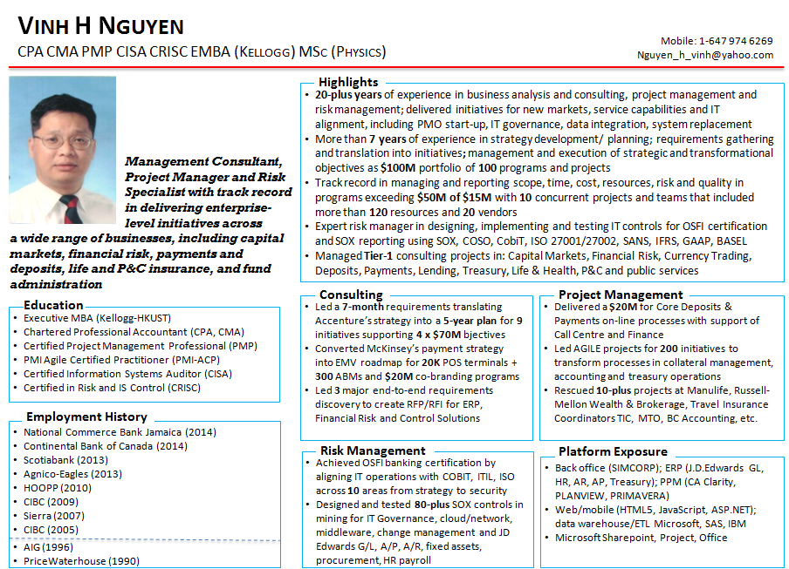

#### Highlights II

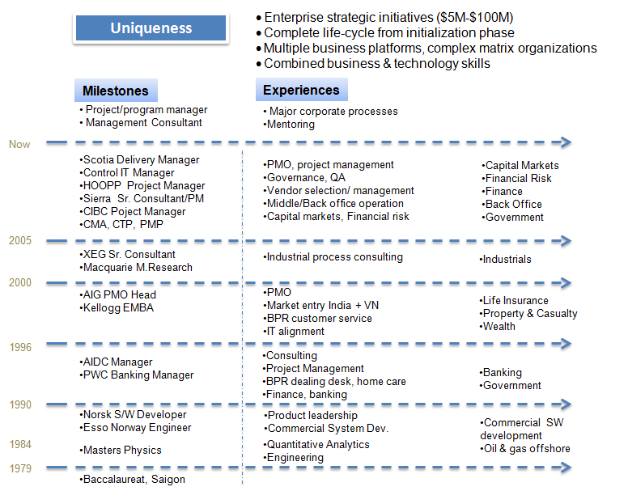

#### Personal traits

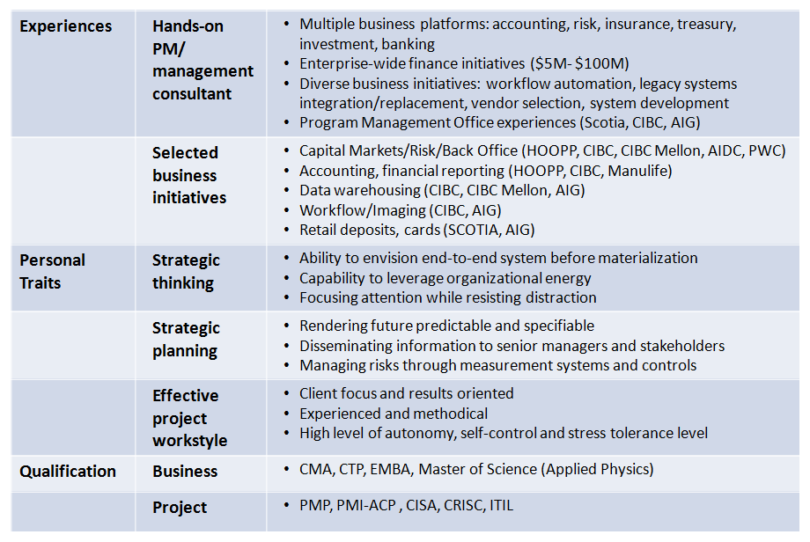

#### On Boarding

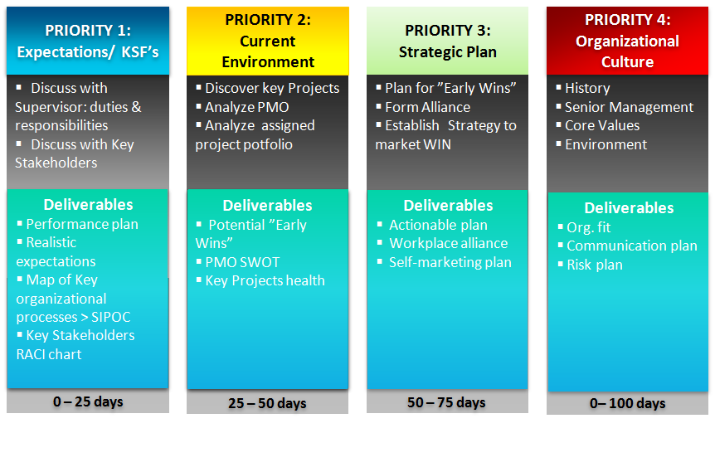

#### Projects

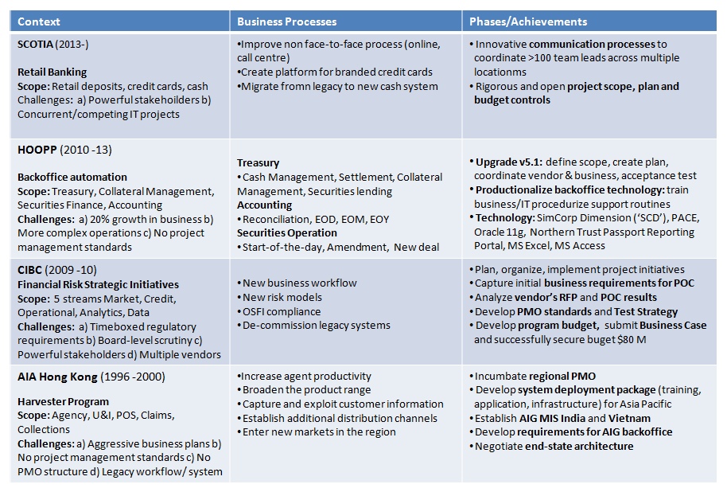

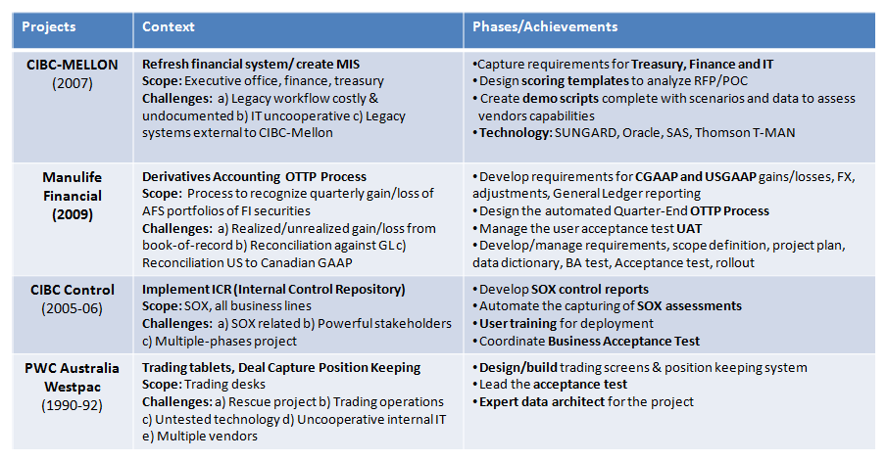

## HOOPP Back Office Upgrade

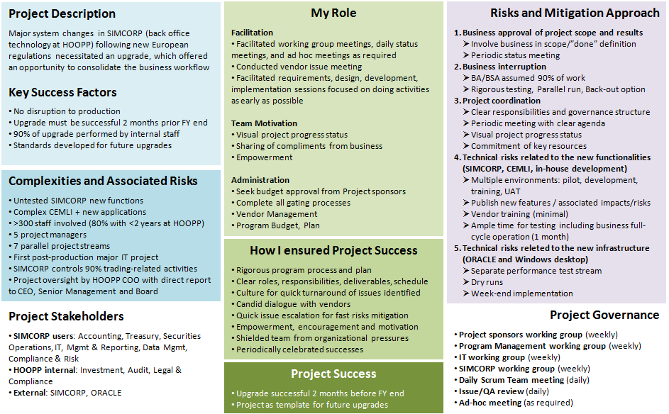

**CEMLI** = Configuration/ customization, Extension, Modification, Localization, Internationalization

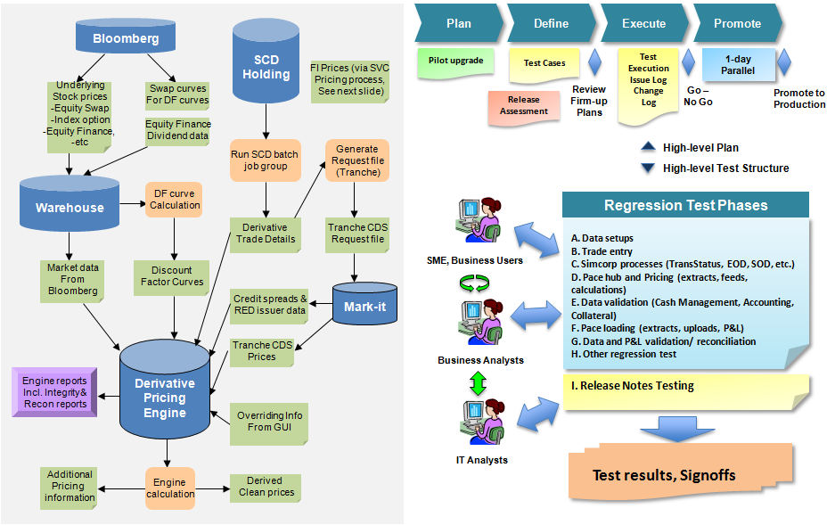

## HOOPP Fair Value Continuity

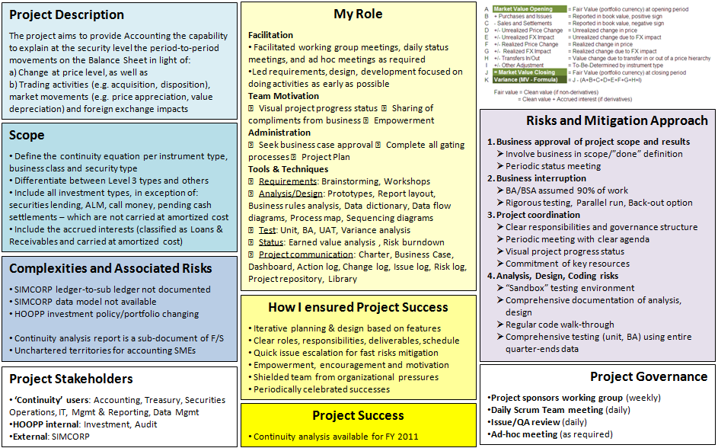

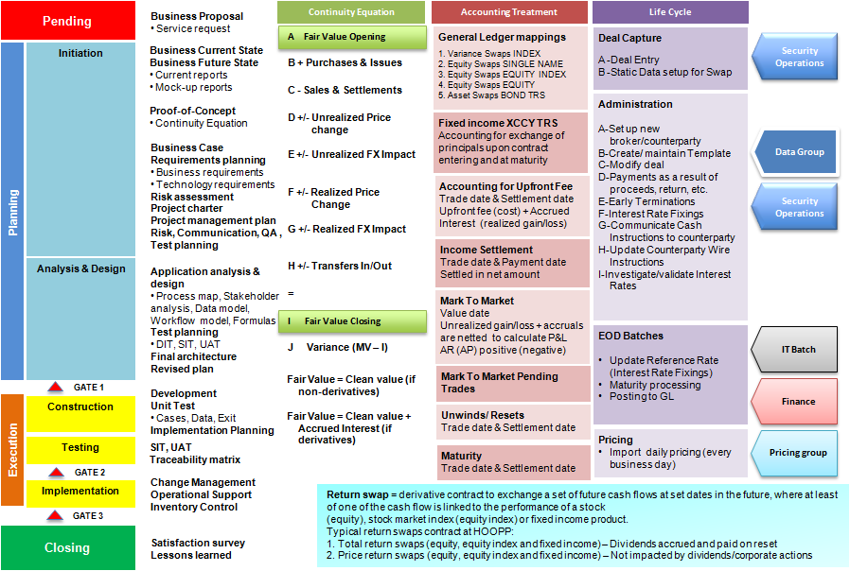

## CIBC Risk Strategic Initiatives

#### Project Overview

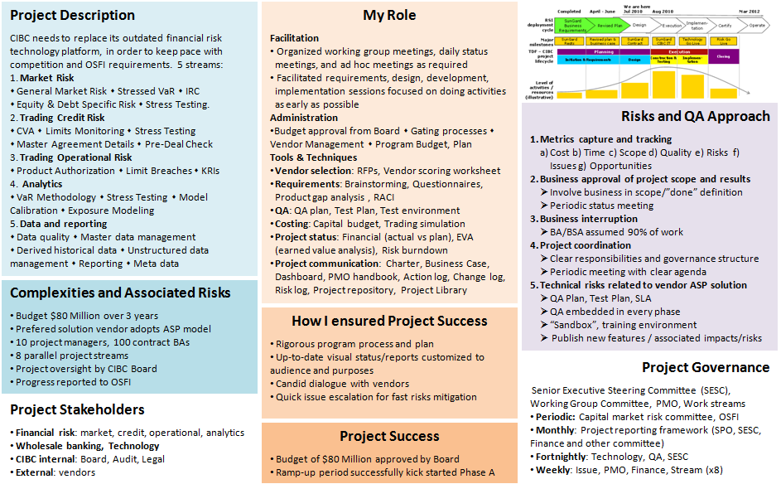

#### RSI Phase A

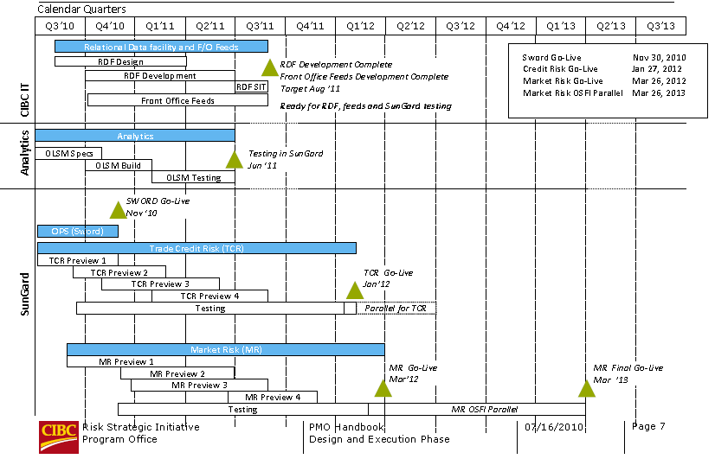

#### RSI Governance

##### PMO as a central point of coordination, control and reporting

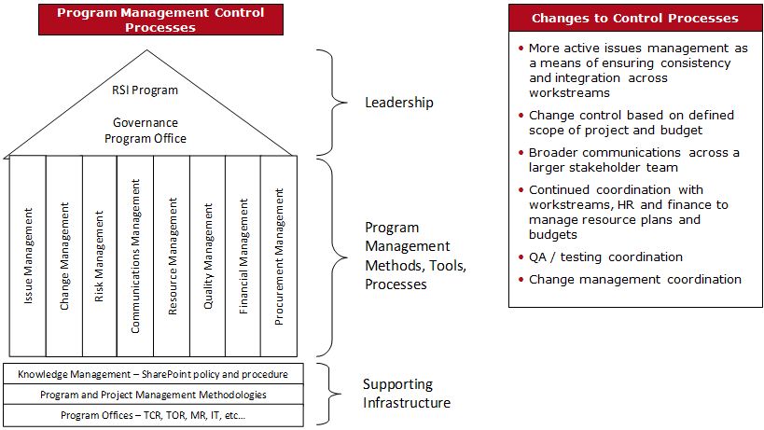

### Work stream’s Autonomy

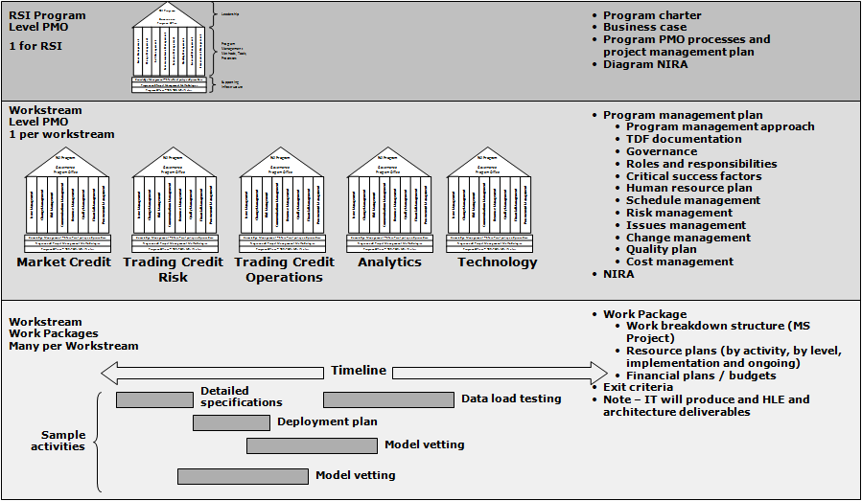

##### Meeting and Reporting

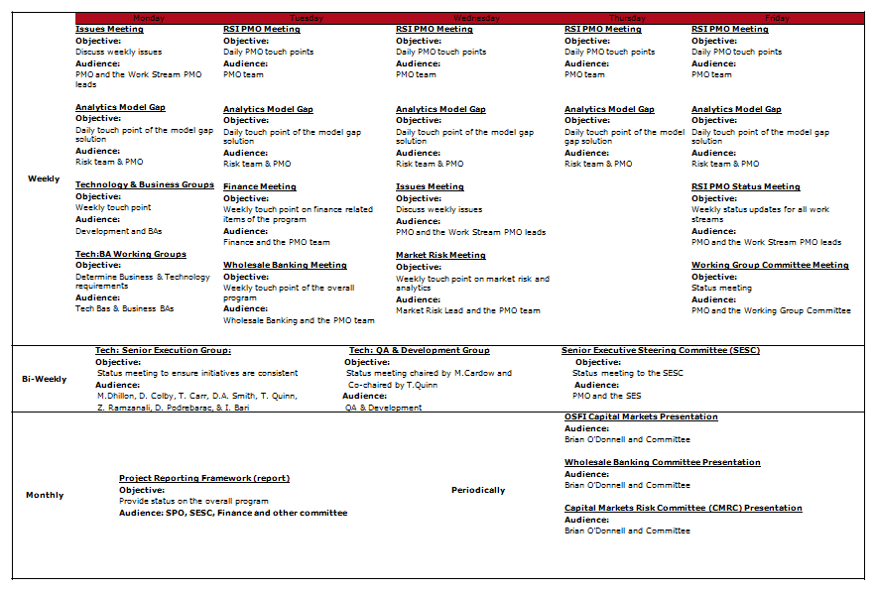

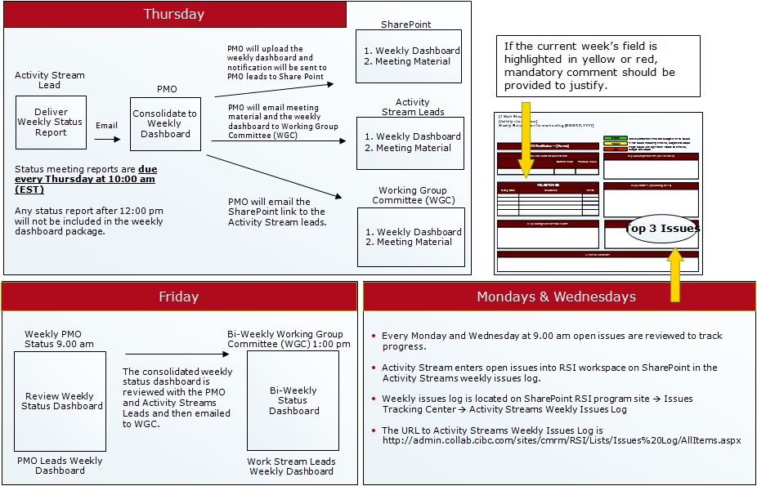

##### Governance

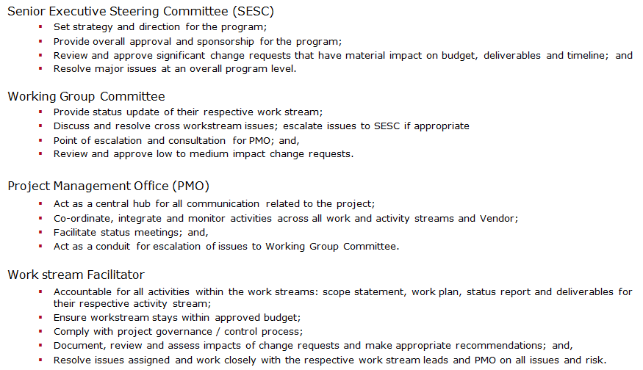

|  |  |
| --- | --- |
|  | **COBIT Mapping**  **Executive committee**  ⬩Evaluate, Direct and Monitor  **Management Committee**  ⬩Align, Plan and Organize  **Operational Committee**  ⬩Build, acquire and implement  ⬩Deliver, Service and Support  **COBIT5 Processes and Practices**  ⬩Processes: 37  ⬩Practices: 210 |

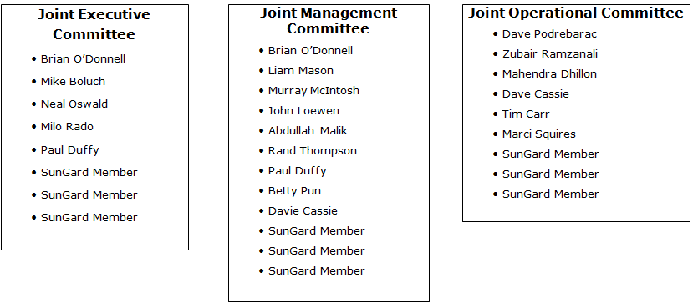

##### Issue Management

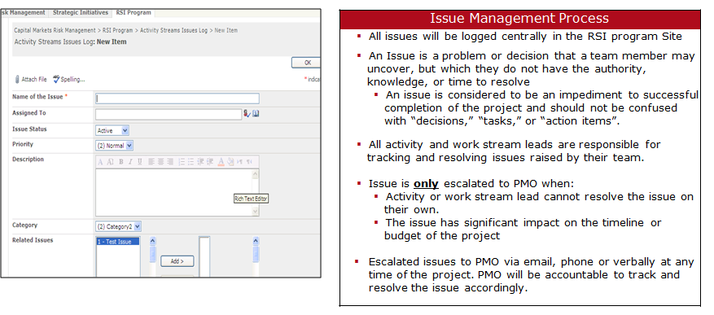

##### Change Control

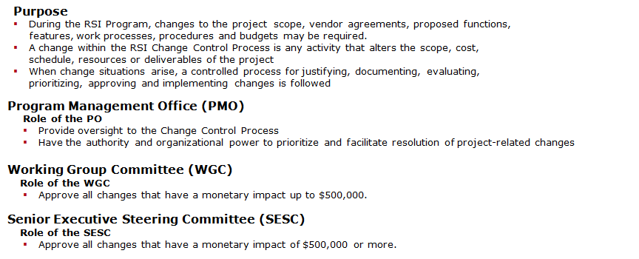

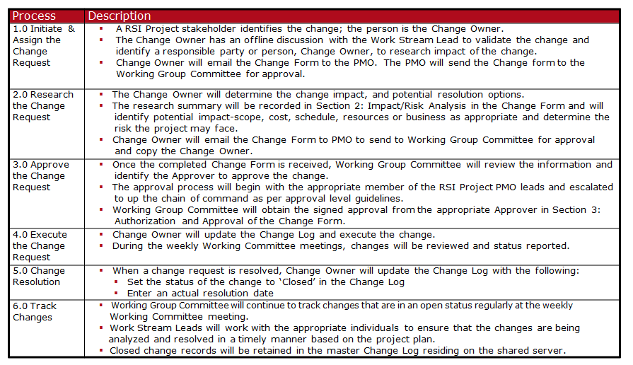

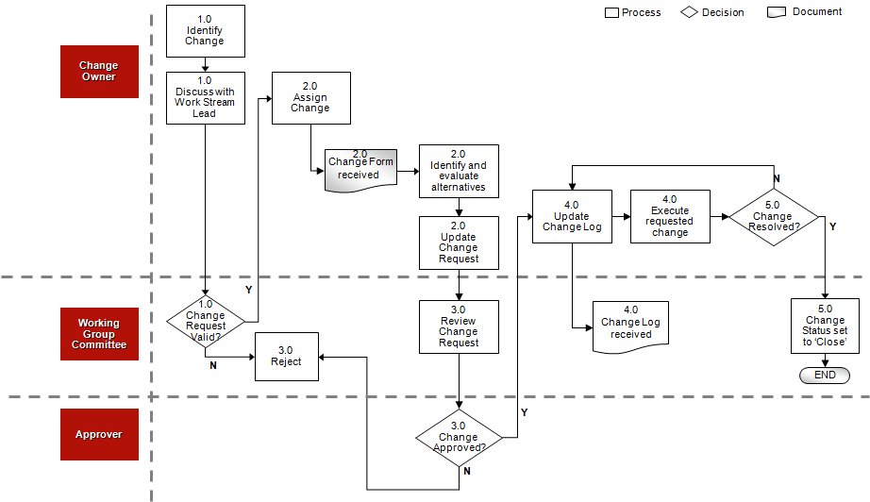

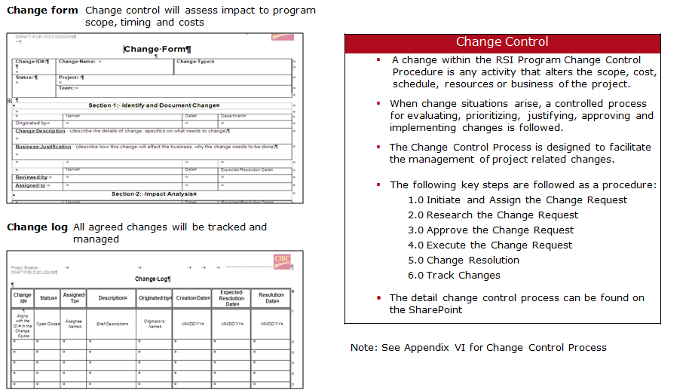

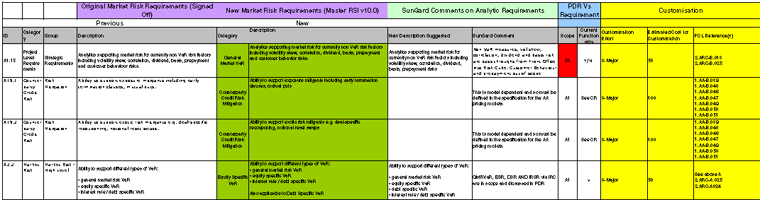

##### Share point

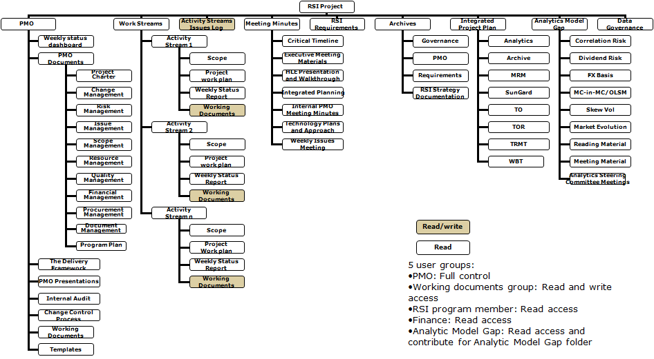

|  |  |
| --- | --- |
| Communication & Coordination | Control |
| Compliance | SHAREPOINT Project artifacts |
| SHAREPOINT Program artifacts | SHAREPOINT Portfolio artifacts |

#### RSI Future State Technology

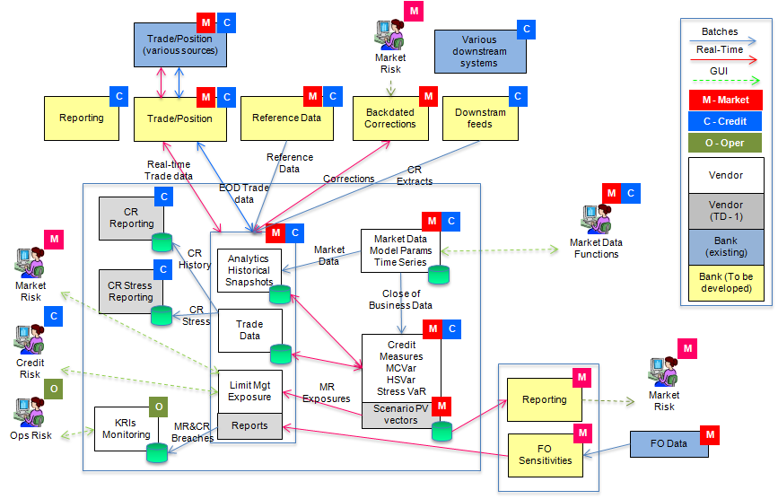

#### RSI Data Feed Schedule

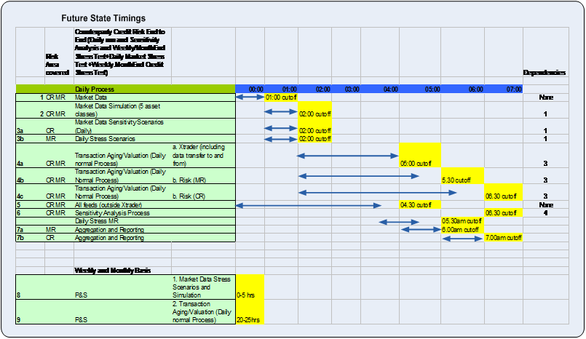

#### Risk Data Facility RDF Future State

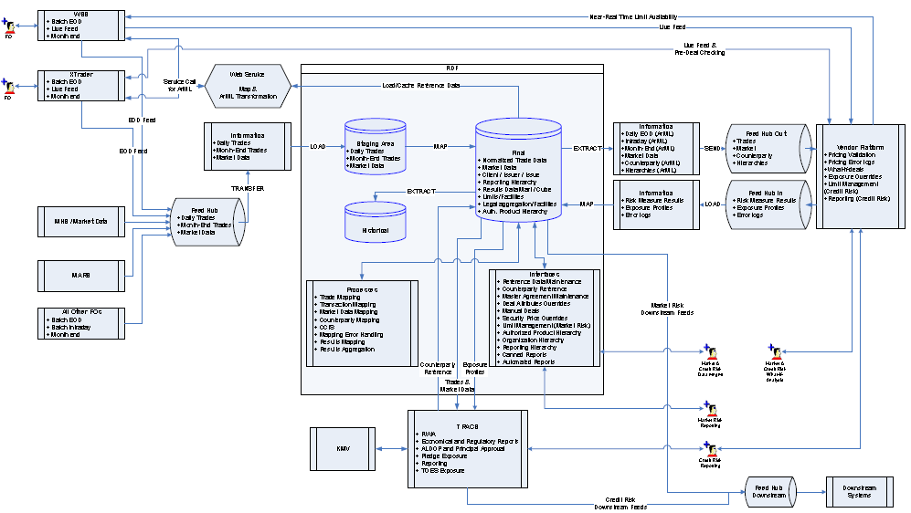

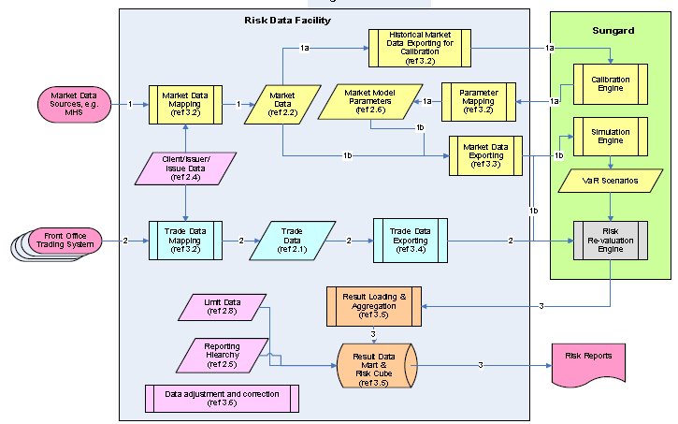

#### Risk Data Facility Functional Areas

**Data Structure/Data Schema (8)** ➊Trade data ➋Market data ➌Scenarios ➍Issuer/Issue Data ➎Reporting hierarchy structure ➏Market model parameters ➐Result data mart & cube ➑Limits **Data Process (8)** ➊Source data mapping ➋Calibrating market model parameters ➌Exporting market data ➍Exporting trade data ➎Building result data mart and cube ➏Data adjustment and correction ➐Run session ➑End of day (EOD) run, incremental run & rerun

|  |  |  |  |
| --- | --- | --- | --- |
| Trade and instrument  Clients, Issuers, Issues  Calibration Models for SUNGARD calibration engines  Market model calibration  Exporting market data  Exporting Trade Data   Run session = calculation process of market spot data, trade data and scenario | | Market Data  Scenarios  Reporting Hierarchy  Results data mart  Data Mapping  Result Aggregation | |
| Run Session | End of Day (regular) | | End of Day (incremental) |

##### Data adjustment and correction

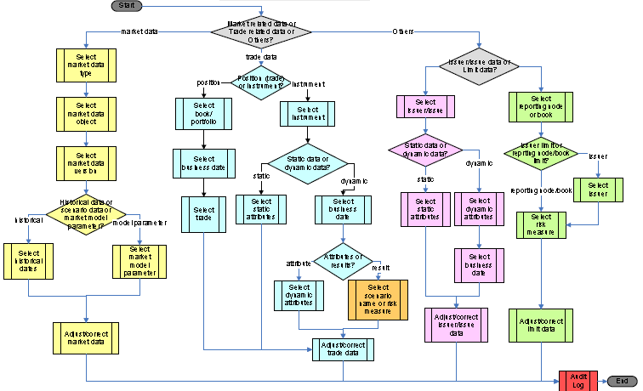

#### SUNGARD technology Sizing

|  |  |
| --- | --- |
|  | ***Sunguard Product Suite hosted at their location:***   * Production (Credit Risk and Market Risk) – Sunguard hosted * Production Stress/Month End (Credit Risk and Market Risk)– Sunguard hosted * CERT/DR (Credit Risk and Market Risk) – Sunguard hosted * UAT (Credit Risk and Market Risk)– Sunguard hosted * UAT Stress – Sunguard hosted * Power User (Credit Risk and Market Risk) – Sunguard hosted * SIT (Credit Risk and Market Risk) – Sunguard hosted * Dev (Credit Risk) – Sunguard hosted * Dev (Market Risk) – Sunguard hosted   ***SQL Database:***   * Prod SQL 2005 Enterprise (Hosts the following environments: Prod, Prod – Stress/Month End) – 2 X IBM3850M2, 4CPUX2core, 32GB RAM, 7.4TB T1 SAN. Two dual port HBA cards will be needed for backups along with Media Server Enterprise Client licenses. * Cert/DR SQL 2005 Enterprise - 2 X IBM3850M2, 4CPUX2core, 32GB RAM, 3.7TB T2 SAN. Two dual port HBA cards will be needed for backups along with Media Server Enterprise Client licenses. * UAT SQL 2005 Enterprise (Hosts the following environments: UAT, UAT Stress) – 2 X IBM3850M2, 4CPUX2core, 32GB RAM, 3.7TB T2 SAN. 2x dual port HBA cards will be needed for backups along with Media Server Enterprise Client licenses. * Dev/SIT SQL 2005 Enterprise (Hosts the following environments: Power Users, SIT, DEV (Credit Risk), Dev (Market risk) - 2 X IBM3850M2, 4CPUX2core, 32GB RAM, 7.4TB T3 SAN. Two dual port HBA cards will be needed for backups along with Media Server Enterprise Client licenses.   ***Miscellaneous Storage:***   * Miscellaneous Storage (Includes Feedhub, Cognos and MQ) – 50GB T1, 50GB T2 and 50GB T3 |

|  |  |
| --- | --- |
| **Solution Assumptions**   * Sunguard will be hosting 9 environments on CIBCs behalf: Production (Credit Risk and Market Risk), Production Stress/Month End (Credit Risk and Market Risk), CERT/DR (Credit Risk and Market Risk), UAT (Credit Risk and Market Risk), UAT Stress, Power User (Credit Risk and Market Risk), SIT (Credit Risk and Market Risk), Dev (Credit Risk), Dev (Market Risk). * Front office systems will send data directly to Sunguard via MQ * Sunguard can provide integration via MQ and SFTP file ingestion. * 514 File Feeds exist today from both the Market and Credit risk areas. The same amount of files will need to be transferred to Sunguard. Sunguard will perform any ETL work that is required in order to ingest the data into their systems. * The database sizing of 3.7TB is based upon the current usage within the Voyager and TRACS * The Dev, SIT, Power user and UAT databases are 1.85TB each which is half the size of prod. * 300 Cognos reports will be required. Each report will be .5MB. * 50GB of storage for Tier 1, 2 and 3 assigned for Feedhub, Cognos and MQ * New SQL DB environments has been specified based upon todays volumes and the fact that there are so many environments. IBM 3850M2’s have been estimated as they can be scaled up by adding another 3850M2 server to double the CPU and memory if required. * The backup standard of daily incrementals and weekly full will be followed. None of the data will be encrypted or compressed on the DB or SAN disk. * 100% allocated space in Prod will be backed up. All other environments assume 80% of the allocated space needs to be backed up. * The existing shared infrastructure for Cognos will have capacity available. * 15mbps primary and redundant links are required between Canada and the UK. Cisco 3845 Routers will be used. * Data center facilities will be available to house all equipment. | **Solution Overview**   * Network Links will need to be setup between CIBC and Sunguards UK location. * The worse case scenario is being scoped out which entails new WAN links between CIBC Canada and London UK Sunguard. * 2 Links will be established as primary and secondary. These are fractional DS3 links that are 15mbps. * 4 routers will be needed for termination. Two physically located in Toronto and two in the UK. Cisco 3845 routers will be used. * MQ Farm used for real time data exchange. One queue manager will be required with 10 queues. * Cognos will be used for reporting purposes. 300 reports will be needed Datasource will be the SQL Datamart. * 514 Flat files will need to be sent to Sunguard for ingestion. Autosys and Feedhub will be used for this process. * A new SQL Enterprise DB farm will need to be created to house the SQL Datamart. These servers will be clustered to provide High Availability. IBM 3850M2’s have been estimated with 4CPU X 2 Cores and 32GB RAM. * Users will access applications hosted by Sunguard via standard IE browsers that are currently deployed on their desktop. This connectivity will occur via the dedicated links. |

#### RSI alignment with EDF

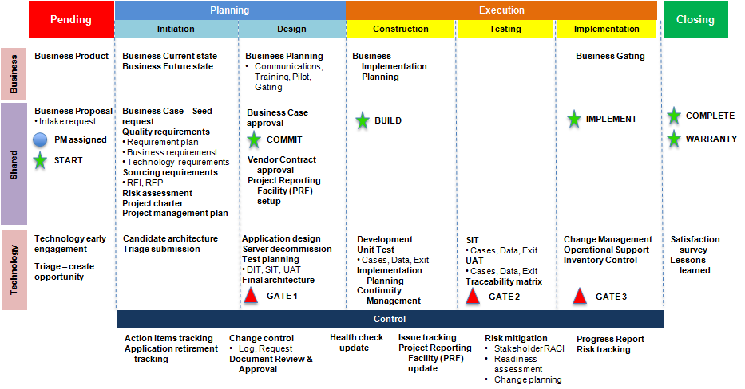

##### CIBC EDF

##### CIBC EDF and PLANVIEW

#### D4 SDLC with Artifacts

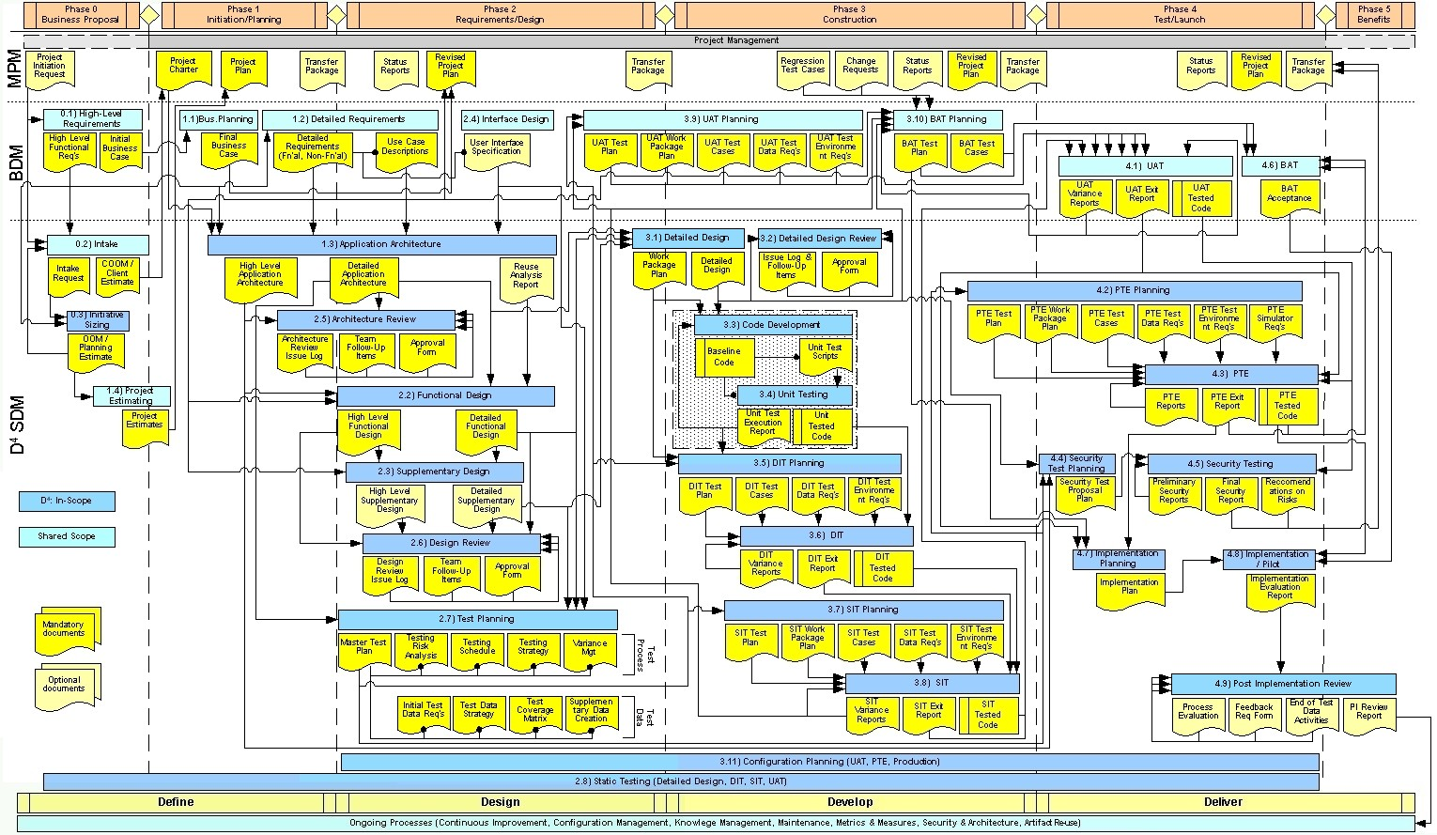

#### D4 SDLC without Artifacts

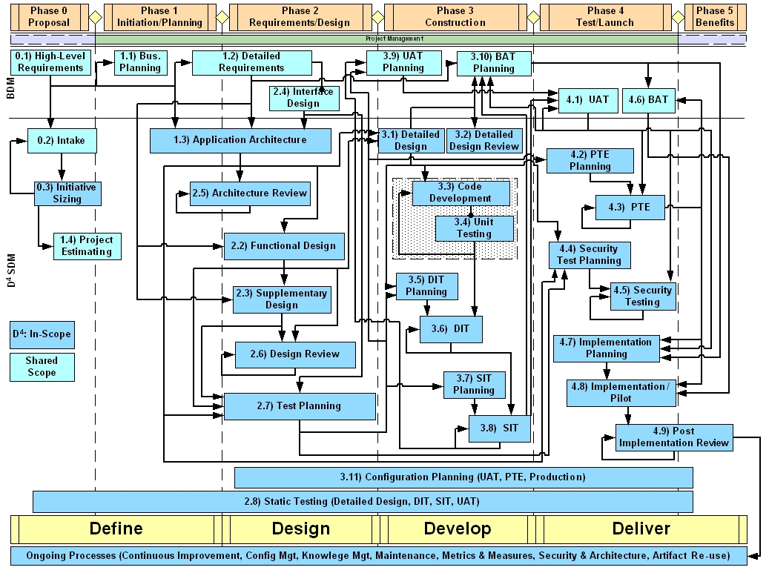

#### Project Portfolio Management (PPM) and Triage

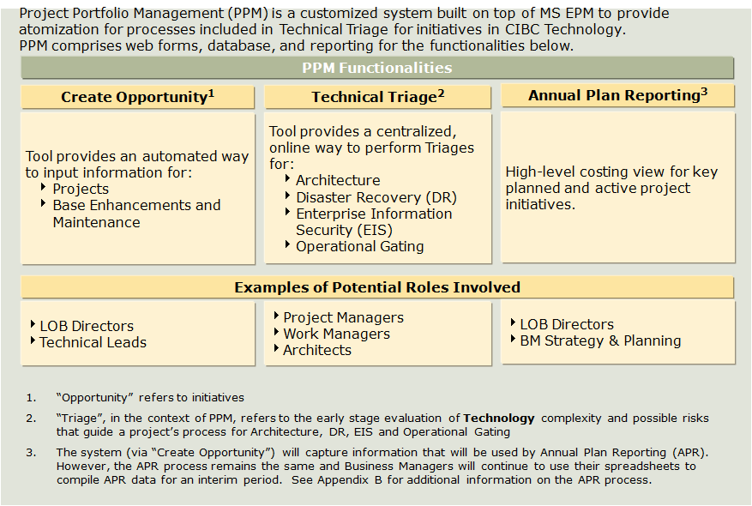

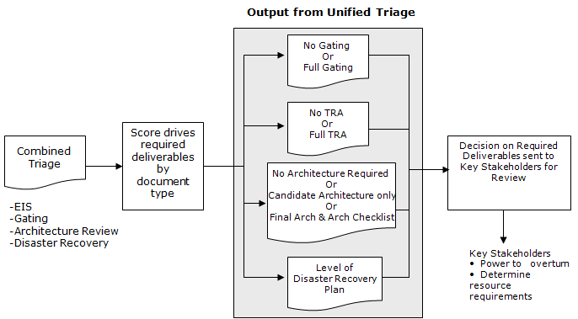

## AIA Hong Kong HARVESTER

#### Portfolio Overview

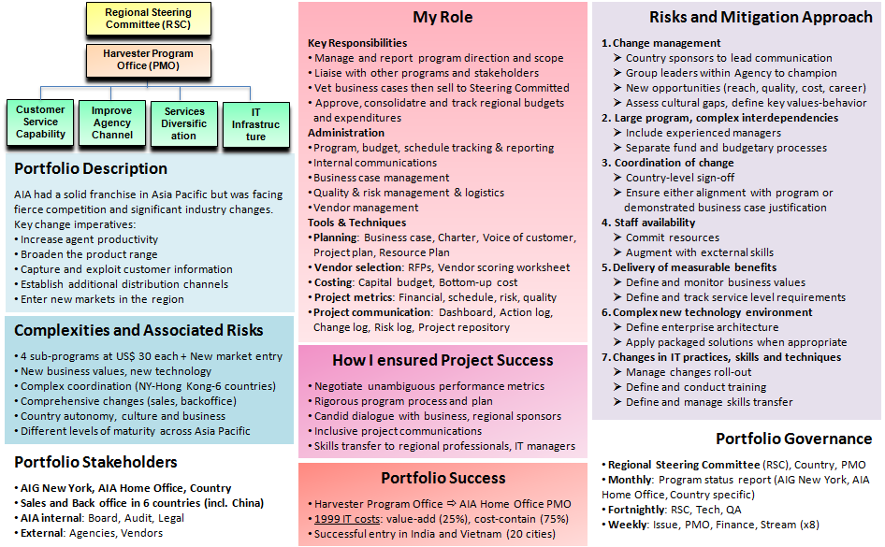

#### PMO setup

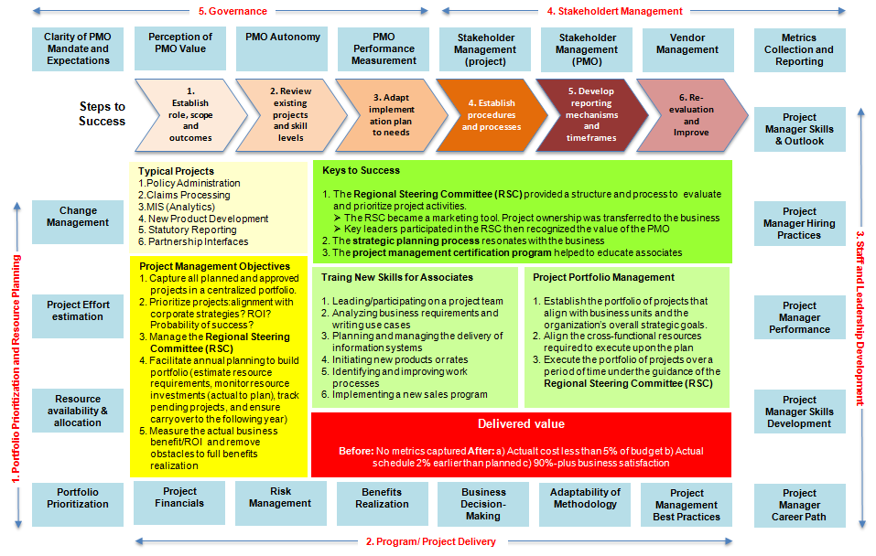

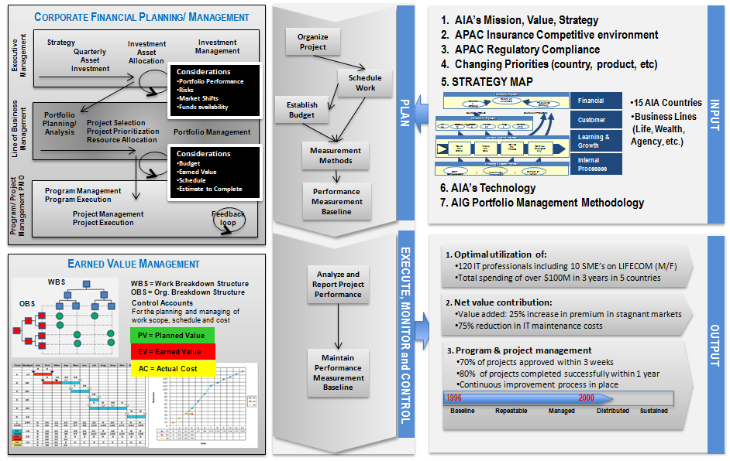

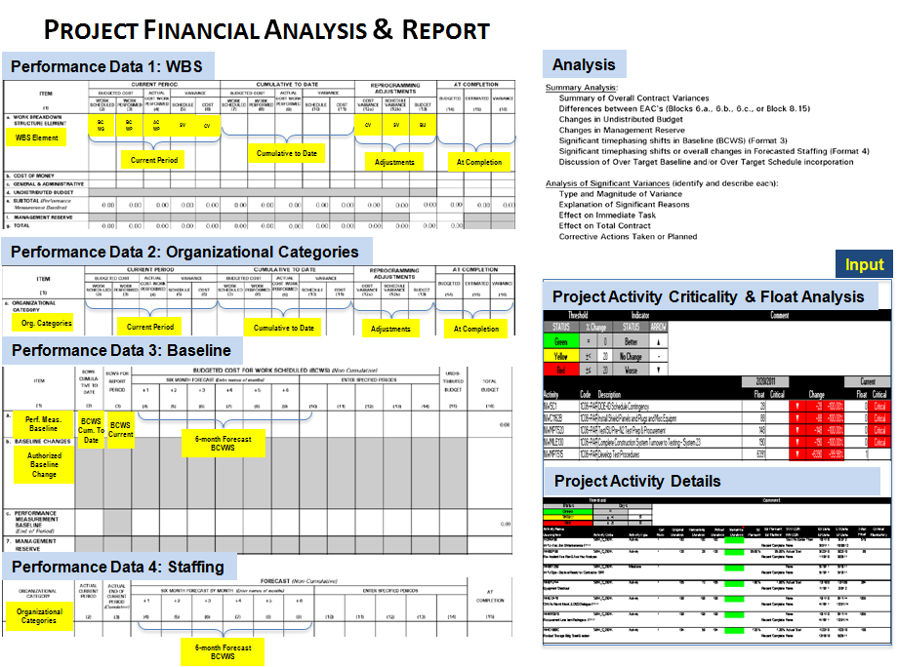

## LIFE Architecture

|  |  |  |
| --- | --- | --- |
| Architecture Design principles | Logical layer (generic) | Logical layer (application) |
| Physical layer | Tools and Languages | Supported platform |

|  |  |  |
| --- | --- | --- |
| Rule engine architecture | Rule management overview | Rules management workflow |
| Rule management multiple environments | Change Management | Development – 2 weeks cycle |
| Process benefits | Internationalization & Security Architecture | Scalability and Fail over |
| Future SOA enhancements | System Integration | Integration Web Services |

|  |  |  |
| --- | --- | --- |
| Integration open database | Integration modern approach | Integration SOA |

## Vendor Selection Toolkit

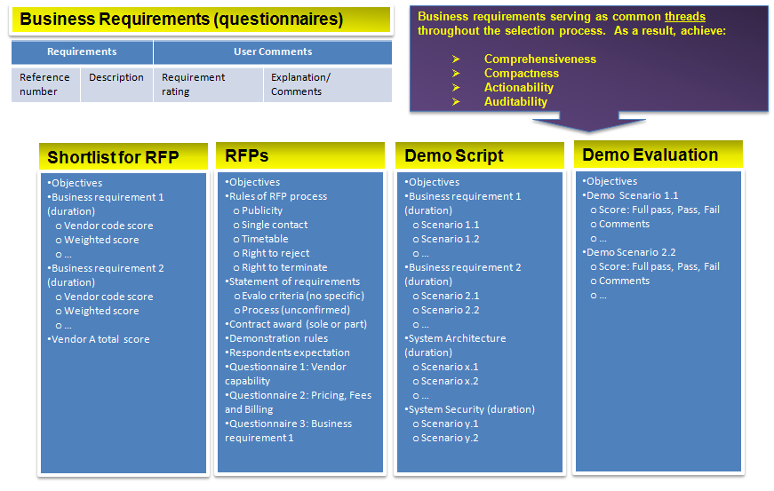

## ORACLE ERP Implementation Methodology

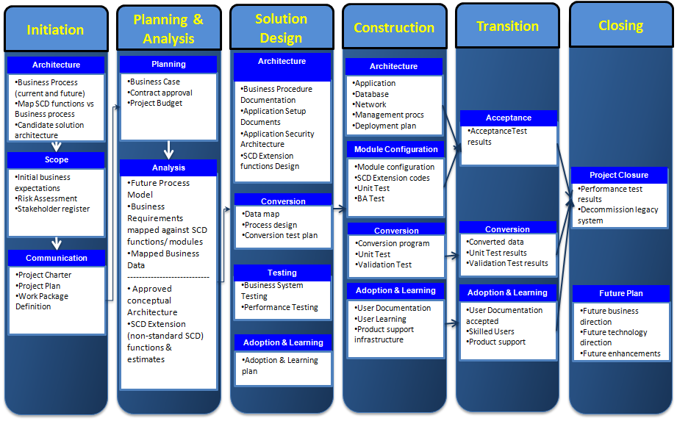

## CIBC Analytics – Model gaps

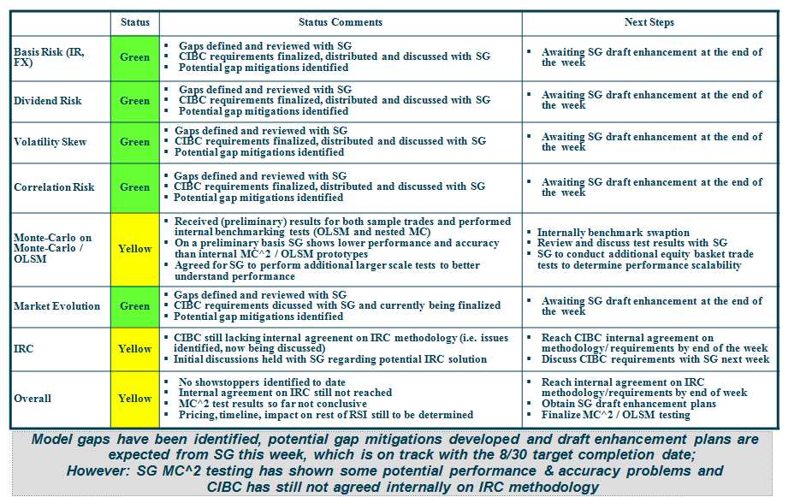

RiskWatch and the SunGard systems have poor capability regarding: • volatility skew treatment, • interest rate bootstrapping to account for intra- and cross-currency basis, and • complex product valuation.

## Treasury Functions and Systems

#### Treasury Management Functions

|  |  |
| --- | --- |
| * **Overview**   + Treasury management is about handling the banking requirements, the funding for the business and managing financial risk.   + Incorporates raising & managing money, currency, commodity and interest rate risk management * **Capital Markets and Funding**   + **Asset and Project Finance**     - International securitised and collateralised debt markets; managing a securitisation, a CDO (collateralised debt obligation) / CLO (collateralised loan obligation) transaction or ABCP (asset backed commercial paper); and public private partnership funding e.g. PFI, PPP including asset backed or asset based loans, leasing and "sale and lease back".   + **Bank Lending**     - Bilateral, club, and syndicated loans – committed or uncommitted, revolving facilities and backstops or standbys   + **Debt Capital Markets**     - Short-term Commercial Paper, Medium Term Notes (MTNs) to bond issues, Convertibles, Exchangeables, preference capital, puttables, callables and hybrid debt with equity characteristics   + **Equity**     - Equity issue including dealing with advisors, pricing, rights issues, bonus issue, IPO; the regulatory matters, listing rules, pre-emption rights and documentation including prospectus requirements, disclosures, accountants reports     - Private equity, venture capital markets and stocklending   + **Trade Finance**     - Open account, export credit insurance, guarantees, supplier / buyer credit, price bases (COD, freight paid etc)     - Trade finance instruments and documentary credits such as Letters of Credit, acceptances, bills, evidentiary e.g. bills of lading. Also supply chain finance and electronic systems * **Cash and Liquidity Management**   + **Cashflow Forecasting**   + **Cash Management**     - Bank account and bank documentation management e.g. SLAs, mandates, signatories, SSIs, Nostros Retail cash management - alternative approaches to physical cash management and security     - Cash management practice in differing jurisdictions.     - Cash concentration techniques: notional pooling, zero balancing, overlays.     - Responsible for regulatory, tax, legal and other cash concentration/ transfer issues such as exchange controls, insolvency, central bank reporting, withholding tax, transfer pricing.   + **Credit Ratings**   + **Payment and Clearing Systems**     - Payments/clearing infrastructures       * RTGS (Real Time Gross Settled)         + CHAPS, TARGET, UK Faster Payments and CLS       * End of Day net settled (BACS, STEP)     - Cheque clearing arrangements, timescales and value dating     - International financial messaging SWIFT     - SEPA (Single Euro Payment Area)     - Payment Services Directive     - Securities and equity clearing systems (Euroclear, Cedel, CREST)   + **Short-Term Liquidity**      - Liquidity management objectives       * Reliability, liquidity, return, relationship management, commercial aspects     - Working capital cycle     - Financial supply chain     - Trade credit       * Credit control, supply relations and liaison with the business     - Short-term investment instruments       * Money market funds, depos, CDs, bills, repos     - Short-term borrowing       * Overdrafts and money market lines | * **Corporate Financial Management**   + **Accounting and Reporting**     - IAS, IFRS   + **Business Valuation**     - Acquisition, disposal, determine whether a business is worth more as a single entity or as a separated sum of the parts   + **Capital Structure**     - Capital Asset Pricing Model (CAPM)       * To determine the cost of equity and cost of capital     - Optimise Weighted Average Cost of Capital (WACC)       * Through its capital structure     - Gearing decision, share buybacks, treasury shares, hybrid capital and the dividend decision   + **Corporate Strategy**     - Treasury strategy, business strategy acquisition, defence strategy     - Private equity, mergers and acquisitions, joint ventures and the concept of shareholder value   + **Investment Appraisal**     - Discounted Cash Flow (DCF) analysis     - Performance measurement     - Cost accounting and accounting based appraisal methods       * Accounting return, marginal costs   + **Legal Documentation**     - Agreements behind common treasury activities       * Taking in loan agreements       * Standard ISDA swap agreements,       * Listing and prospectus requirements   + **Regulation and Law**   + **Taxation**     - Domestic and International tax aspects       * Branch vs subsidiary       * Transfer pricing       * Thin capitalization       * Double tax planning,       * Corporate reorganisations * **Risk Management**   + **Business and Operational Risk**     - Economics (micro/macro), monetary/fiscal policy, financial system     - Types of business and financial risk       * Strategic, market, credit, gearing, refinancing, operational, technology     - Deals with the insurance market and insurance products and captive insurance aspects     - Planning for business or whole market interruption and contingency planning including shadow sites, key personnel, emergency liquidity   + **Commodity Risk**   + **Credit Risk**     - Managing credit and counterparty risk     - Credit analysis and credit ratings     - Credit insurance, credit derivatives, collateralisation, security     - Credit risk models, Basel II, duration hedging   + **Exotic Risk**     - Inflation, weather, index linked derivatives, weather derivatives, emissions trading.   + **FX Risk**     - Risk from transaction, translation and economic exposures     - Managing risks with FX forwards, currency swaps   + **Interest Rate Risk**   + **Managing Risk**   + **Pensions Risk** * **Treasury Operations and Controls**   + **Control and Reporting**   + **Policy and Objectives**   + **Technology and Systems** * **Treasury Organisation** |

#### Treasury Function at AIDC

|  |  |
| --- | --- |
|  |  |
|  | Treasury at CIBC |
|  |  |

|  |  |
| --- | --- |
| Treasury Management System | SUNGARD |
| SAP | |

## SIMCORP Dimension

#### Overview

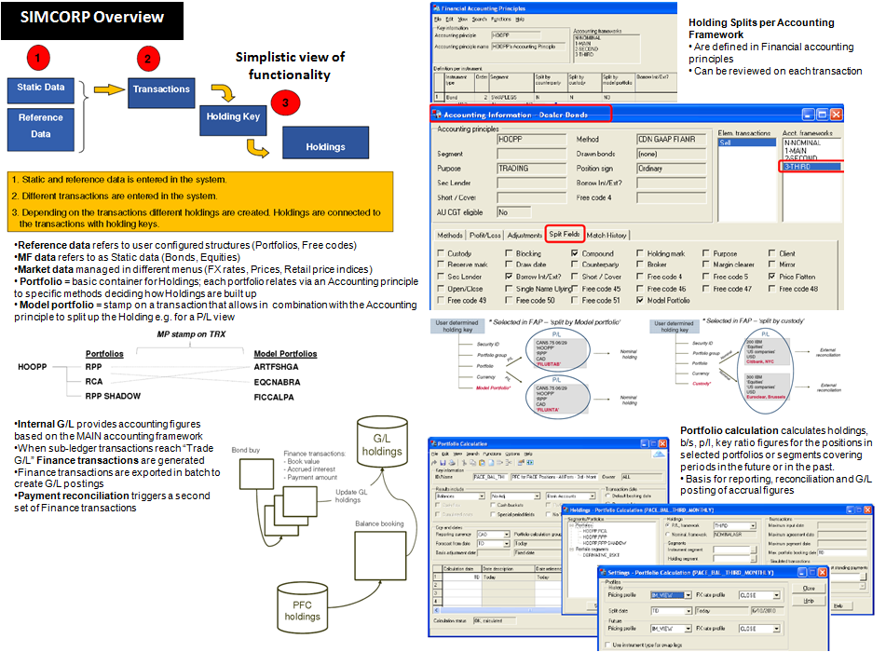

|  |  |
| --- | --- |
| Data Extractor | Collateral Pool |

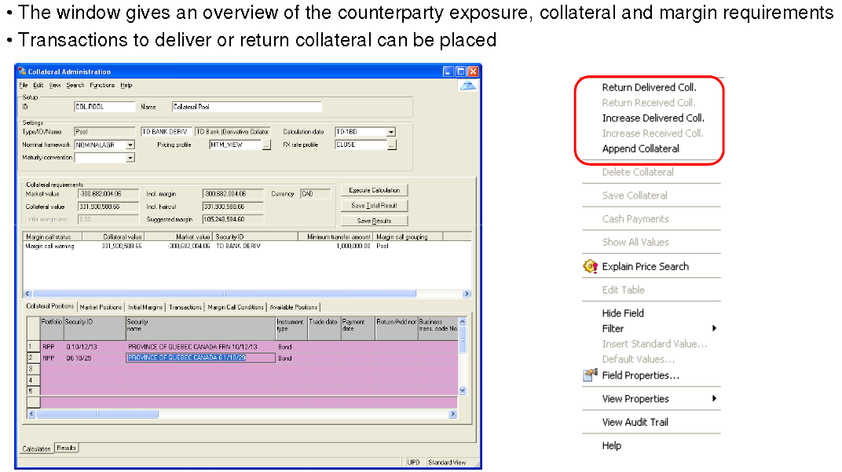

#### General Configuration

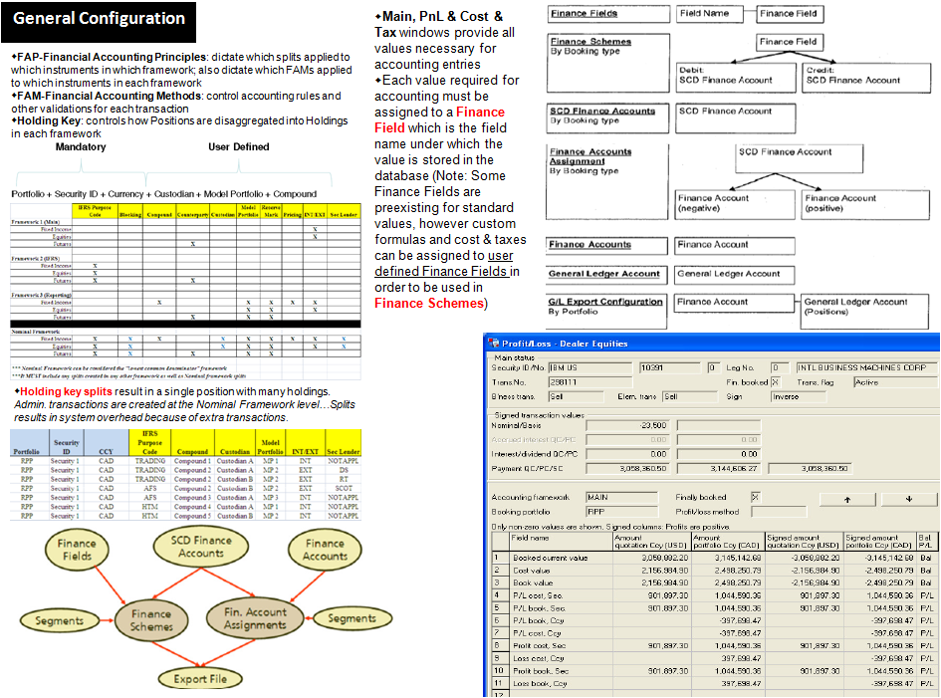

#### G/L Configuration

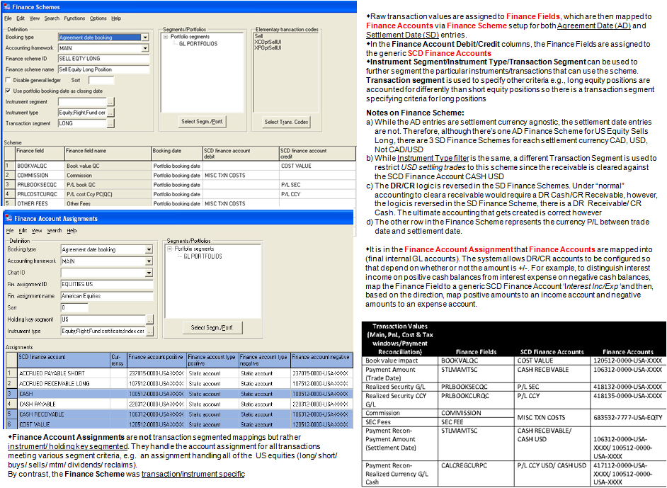

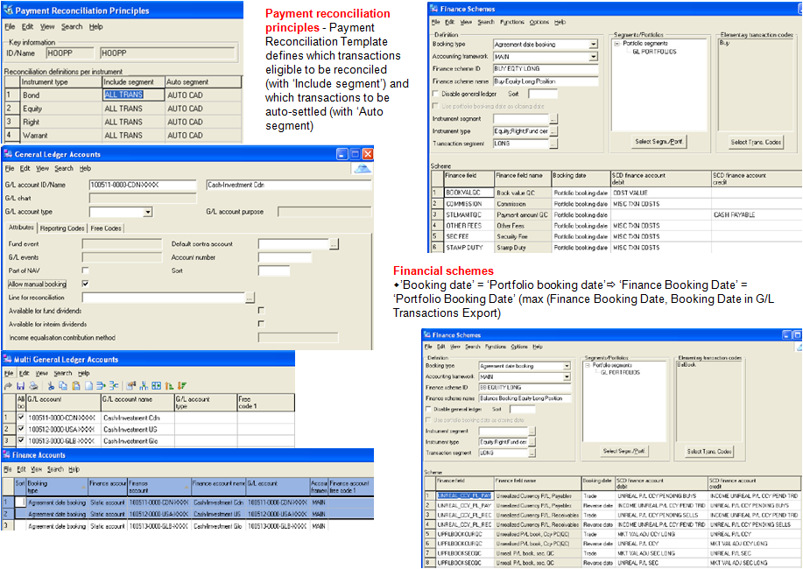

#### Portfolio Figures

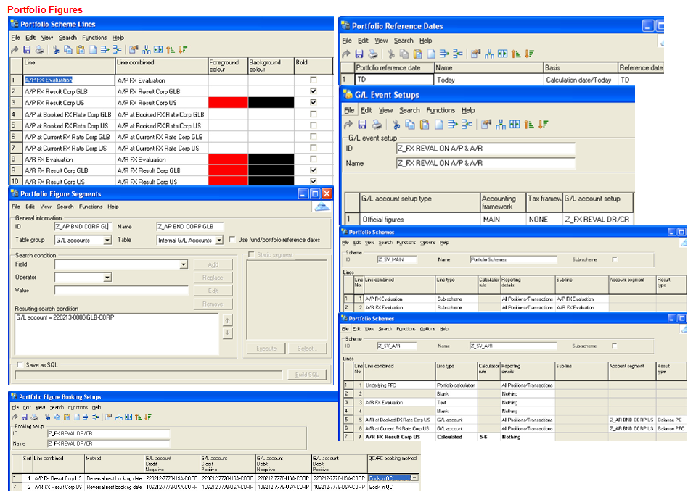

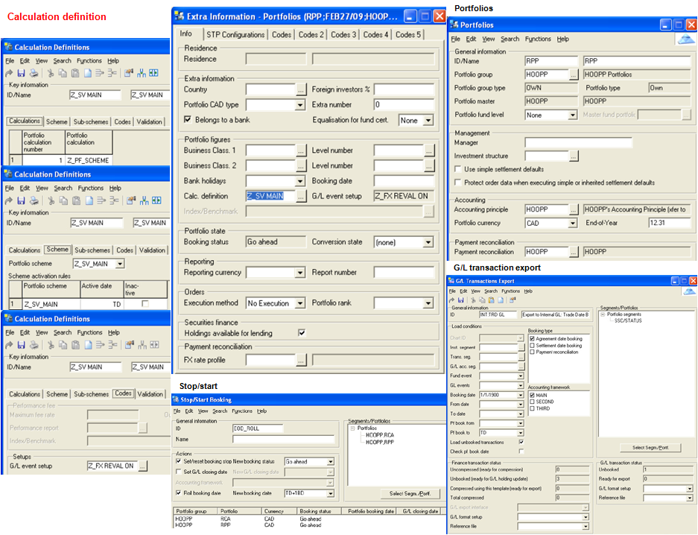

## HOOPP Asset Mix Report

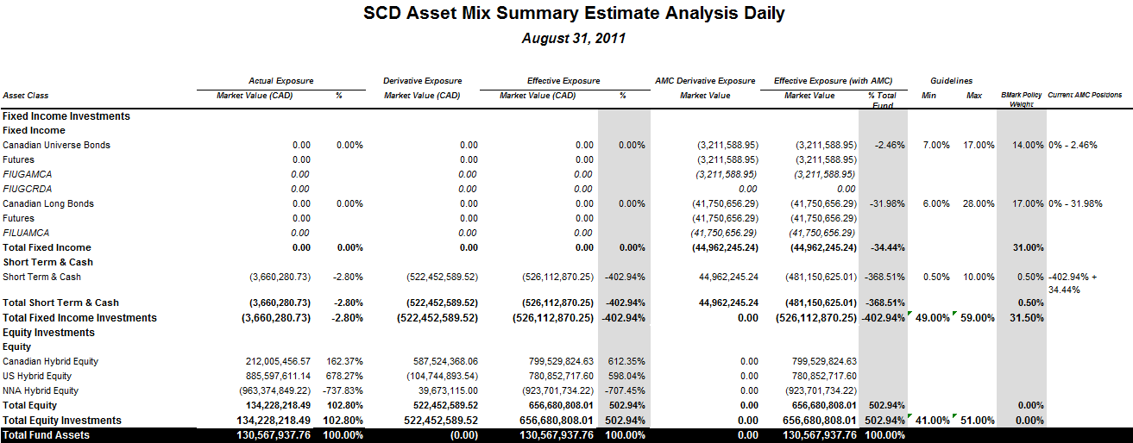

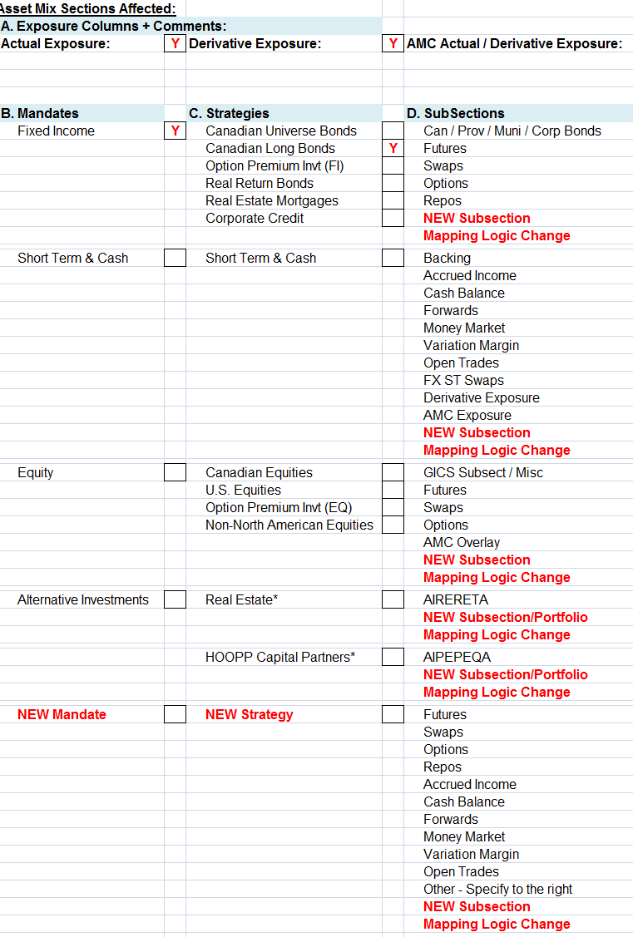

## Trade Workflow

#### Domestic equities/FI process flows

|  |  |
| --- | --- |
| Current State | Future State |

**Fixed Income NOE** = Notice of Execution - **Equity ICI** = Indications of Interest

##### Implementation challenges

**Communication** ensure all parties informed & aware of online trading process change Institutional **Transaction processing** overcome regulatory hurdles to implement matching model (modify confirmation/ requirements, implement new process deadlines) **Payment processing** Get support of banking, broker/dealer community Identify alternative payment

**Physical securities & Dematerialization** Technical obstacles, legal & regulatory concerns, consensus brokers/dealers, transfer agents, investors **International/Foreign exchange** International endorsement, changes in fund & trade mangement, transactional & technological changes **Clearance/Settlement** Changes in process, replace batch process with real-time and near real-time processes, technical I/F and real-time proceses

#### STP, Clearing, settlement

|  |  |
| --- | --- |
| Workflow for central clearing OTC derivatives | Straight-through Processing STP workflow |
| Intranet trade process | Trade floor design by STP |
| To-Be trade cycle | Moving from T+1 (2000) |
| Trade floor sequence diagram | Traditional trade settlement workflow |

## Interest Rate Swap Screen dump

|  |  |
| --- | --- |
|  |  |

The closing amount can only be calculated by entering a closing price. In the example below the price is set to 99,90 for the fixed leg, which may be obtained from the swap calculator

## Fixed Income Trading

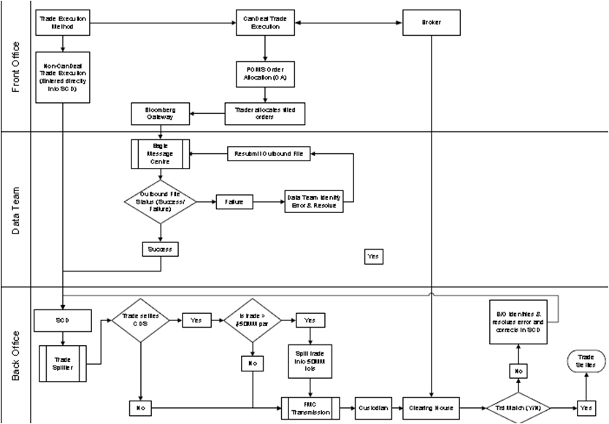

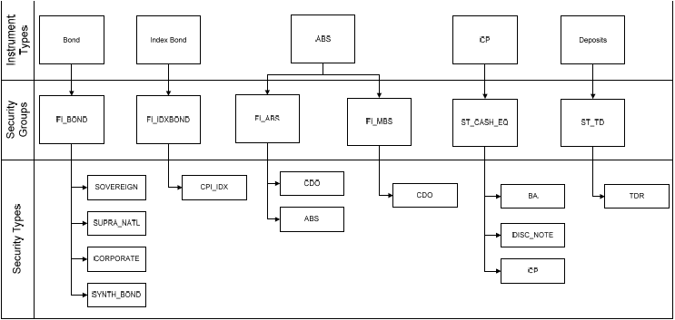

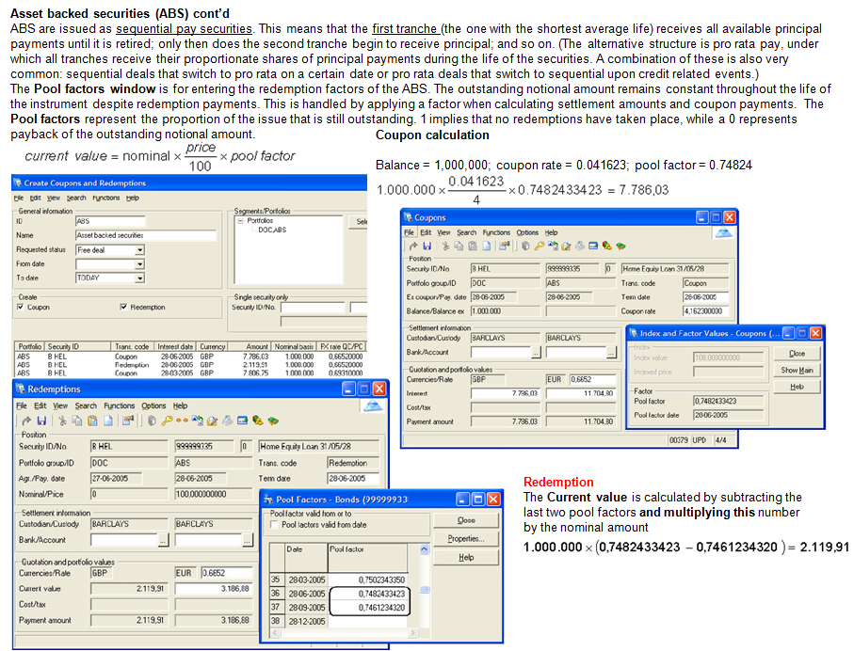

## SCOTIA Non Face-to-Face System Overview

#### NFF Future State

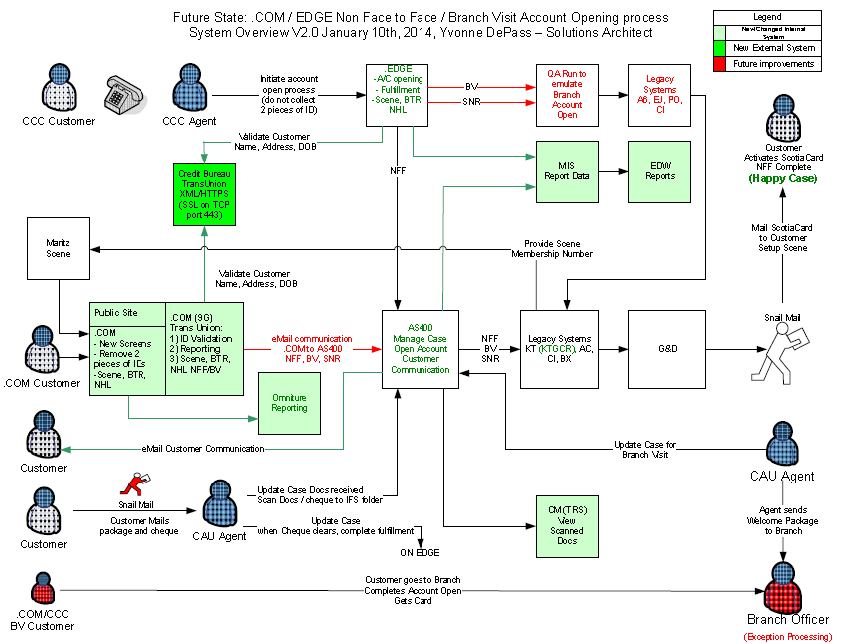

➊.COM enhanced screens & customer analytics to see why customers are disengaging. Welcome Package provided via .COM ➋New connection from .COM + CCC to Credit Bureau to validate address while customer still engaged at those channels; If name & address not validated offer customer Branch Visit to complete fulfillment ➌Offer Scene & Bank the Rest recommendations ➍Provide Click to Chat to help customers & keep them engaged to complete application ➎Provide Customer eMail communication for fulfillment package and next steps/status of the application ➏Provide reports for application including success rate of completion and fulfillment ➐Address system failure points in order to increase fulfillment rate ➑Streamline CCC/EDGE account hold function via AS400/KT ➒Streamline CCC/EDGE BV/SNR account opening function via AS400; 2 pieces of IDs requirement met by services in AS400 rather than changing 4 systems (QARun/PO/EJ/A6). Better use of funds for initial and to save ongoing costs

#### SCOTIA Email and Click-to-Chat/Talk

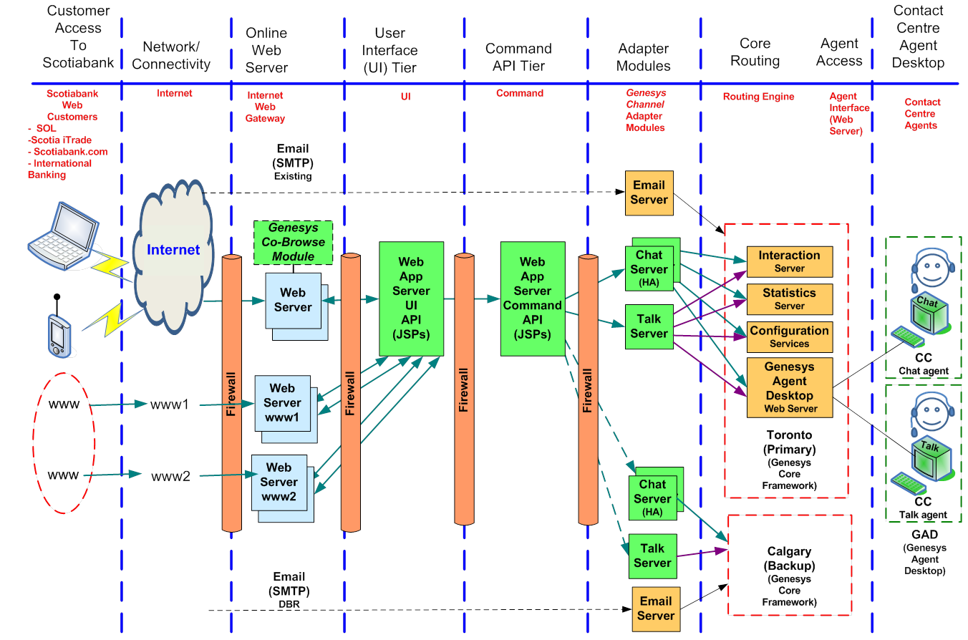

#### Functional View

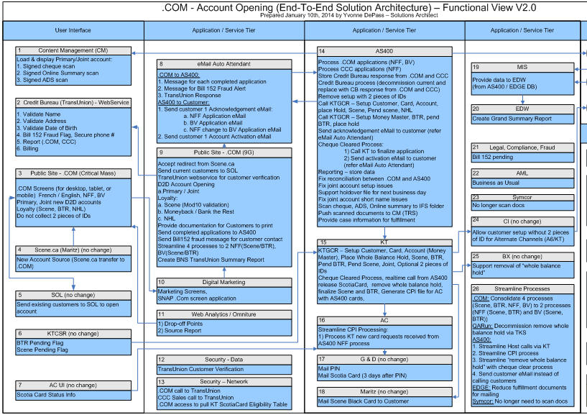

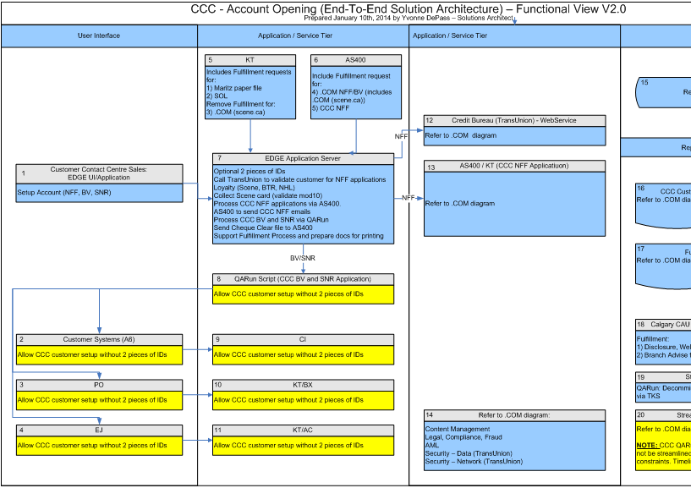

## SCOTIA family of cards

#### FOC Time to Market

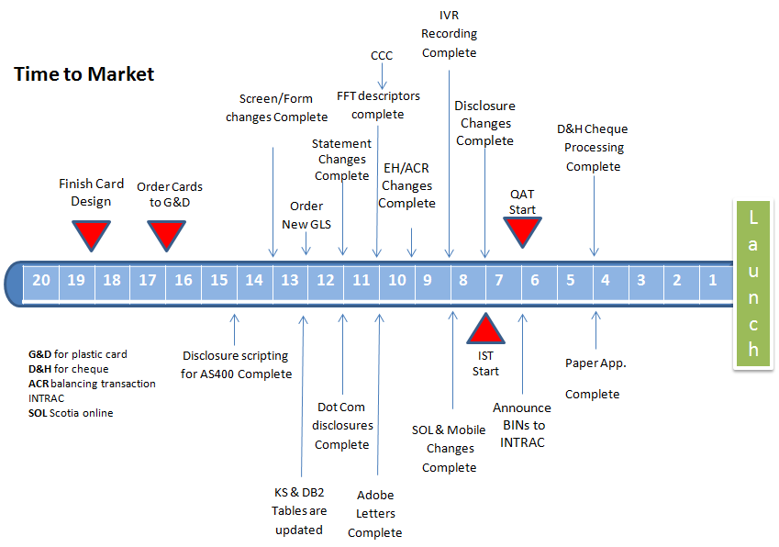

## SCOTIA Direct Loan

#### Flow Diagram

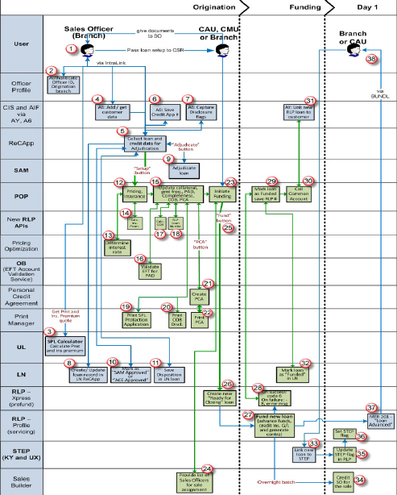

#### Context Diagram

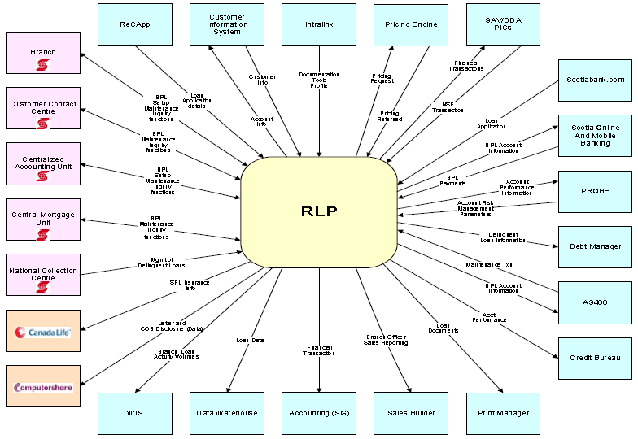

## SCOTIA Retail Glossary

#### From Family of cards

| **Term** | **Definition** | **Term** | **Definition** |
| --- | --- | --- | --- |
| **A6** | Application mnemonic for the Common Customer IntraLink application | **G&D** | Giesecke & Devrient (Plastics manufacturer) |
| **AY** | Application mnemonic for the Common Account IntraLink application | **GL** | General Ledger |
| **ACR** | Auto-Balancing Control Report (KS host reports produced by EH) | **IBS** | Integrated Business Solutions |
| **ACT** | Authorization Control Table | **KS** | Visa/ScotiaLine System (Host system) |
| **APR** | Annual Percentage Rate | **KT** | Online Channels Front-end System (SOL, CCC, .com, AS400) |
| **AS400** | Call Centre System - Manages the set up/maintenance of products for all non-branch channels and statement reprints | **KV** | Visa/ScotiaLine Front-end System (Branch) |
| **BKO** | Banking Operations | **KY** | Web Front-End for STEP |
| **BSRL** | Banking Solutions Retail Lending | **MDM** | Master Data Management – consists of 2 applications:  **8N** – MDM Integration  **OS** – Customer MDM Extensions |
| **CBRC** | Credit Business Regulatory Changes | **PBP** | Performance Based Pricing rate (see APR) |
| **CCC** | Customer Contact Centre | **QAT** | Quality Assurance Testing |
| **CCV** | Click, Call, Visit (SOL application) | **RAS** | Retail Application Services (supports control table keying) |
| **CIS** | Customer Information System generally refers to the database(s) which hold customer information and some account level information. | **RCSD** | Visa Systems Development |
| **CO** | Collections Batch portion | **ReCApp (HB)** | Branch Retail Credit Application System (Branch Application Set Up) |
| **COB** | Cost of Borrowing | **RU** | Revolving Credit WEB Front-end (Branch Account Set Up / Maintenance) |
| **CR** | Change Request | **RLI** | Record Level Interface transactions from AS400 to Host |
| **D2D** | Day to Day Highway (Visa/ODP Cross-Sell Flow) | **RFP** | Request for Proposal |
| **D+H** | Davis + Henderson (Cheque manufacturer & AS400 front-end paper Apps) | **SAM** | Scotia Adjudication Module |
| **EDW** | Enterprise Data Warehouse | **SSCE** | Self Service Customer Experience |
| **EH** | Application mnemonic for the ACR Balance reporting system | **TTP** | Time to Pay message |

#### From Retail Loan Platform

|  |  |  |  |
| --- | --- | --- | --- |
| **Adjustment Factor** | The difference between SCOTIA Prime Rate, and the customer’s actual rate (aka Rate Spread) | POP | **Product Origination Process** standard 3-tier web application (web-based user-interface + web service layer + database to store product origination data); integrated with INTRALINK framework, includes services (including iWay services) that communicate with other Bank applications; serve branch channel, as front-end system that facilitates data gathering, for the setting up new lending products (and related creditor insurance products); introduced with the OEI Pre-fund Retail Enhancement project (Nov 2013, application mnemonic ‘IS’) |
| **Branch Address** | Address of the customer’s servicing branch | **Processing Transit** | The branch where the credit application was done (aka originating transit) |
| EDW | **Enterprise Data Warehouse** houses all data elements required by the predictive models and supporting Analysis- monitoring- reporting activities for calibrating the pricing decisions; establish history as the book of records for pricing | **Security Code** | A sub-category of collateral. |
| ICSS | Insurance Canada Systems Support | **Security Type** | A category of collateral. |
| IS | Application mnemonic that identifies all the components of the POP application; standard 3-tier application, serving branches: screens on INTRALINK + service layer on iWay + POP database that stores data pertaining to the product origination process. | **Servicing Transit** | The branch that is setting up the loan (i.e.: transit of the current user) |
| KY | Application mnemonic identifying the front-end of the STEP system | **Trigger Rate** | Interest rate at the time of variable loan setup. |
|  |  | UL | Retail Lending product front-end on INTRALINK (KS Visa Product, SPL, Credit Bureau report function and student loans) |

#### Scotia Products

|  |  |  |  |
| --- | --- | --- | --- |
| SPL | **Scotia Plan Loan Life & Disability Protection** (with Canada Life) Unlike ordinary life insurance, life portion of insurance goes directly towards paying off loan | Scotia Mortgage Protection | Scotia Mortgage Life Coverage, Scotia Mortgage Critical Illness Coverage, Scotia Mortgage Disability Coverage |
| STEP | **Scotia Total Equity Plan** - Borrow up to 80% of the value of your home and choose from a broad range of products. Once the STEP is in place, you decide how and when you'll use your available credit. Secure your borrowing with at least 20% equity in your home. Apply just once to establish your overall borrowing limit. Manage your interest rate risk by splitting your mortgage into two or three different types of mortgages and terms. Choose a combination of other secured borrowing products† that best suit your needs, up to a total of 65% of the value of your home: Fixed Rate Mortgages, Variable Rate Mortgages, Long and Short® Mortgage, Personal Line of Credit, Credit Line for business, ScotiaLine for business VISA* card, ScotiaGold Passport for business VISA Card, Scotiabank VISA* Card, Scotia Plan Personal Loans, Term Loan for business, Overdraft Protection | | |

#### Family of Cards Interfacing Systems

|  |  |  |  |
| --- | --- | --- | --- |
| **Code** | **Assumptions / Changes** | **Code** | **Assumptions / Changes** |
| ABM | Control ABM processing - Centralized table of BINs + descriptions replace hard coding. Add 24 FC&S sub-products to this table | IVR | **IVR Card Activation** - Telephone card activation - IVR will have recordings for the 6 FC/S prod/subproducts that will have plastics testing in QAT |
| AC | **Access Control System** - Maintains the linkage of product accounts to the customer’s ScotiaCard - Supports Host PIN selections Descriptors for KS product/sub-products retrieved thru KS Interface RBBF (KSCNQ) [from KS Product Master Tables]. AC will support the following: ⬩Linking to ScotiaCard ⬩Store FC&S accounts on AC CIF DB as ‘A’ ⬩Credit Card (i.e. VISA or Amex) Chip PIN process ⬩Contactless – not for Amex ⬩Host PIN selection ⬩AC will receive indicators from KS to control processing replacing hard coding of BIN | JU | **PROBE Customer Scoring System** - Supports the scoring of customers based on statuses and conditions of the various accounts linked to that customer - KS will pass the FC&S accounts to JU for Probe assessment in the same manner as current VISA/Amex accounts. Probe processes KS accounts at product level, so will add 28 FC/S product codes. There is no change in the existing interfaces between KS and JU for this project. JU will align the products to the existing VISA strategies, i.e., VFA/AFA: same as VCL RG - VFB/VFC/VFF/VFG/AFB/AFC/AFF/AFG: same as VGD RG - VFP/AFP: same as VCL DM |
| ACE  (U9) | **Adjudication Centre of Expertise** - Process adjudication request from ScotiaWorx | KN | **Credit Insurance Fulfillment** - Design and Print Letters of Fulfillment (welcome packages and certificates) for Scotiabank Customers that purchase Creditor insurance on Mortgage, Credit Card and ScotiaLine products - KN is sun-setting in Dec 2013. |
| ALSCOM | Front-end for auto-dealers for Steel Branding phase | KT | **TeleScotia / Scotia OnLine System TeleScotia, ScotiaOnline** and **Mobile Banking** - Supports the electronic customer activated delivery services for customer telephone banking and PC banking -  The changes for VRU (voice response), PC (online screen descriptor / Web application Dev) and CSR (Screen scrappers) to recognize the new product/sub-products will be handled by SSCE. KT hardcoding to be removed, KT Descriptors for various screens will be determined by the KS product/sub-products and will be provided by the KS RBBF (KSCNQ), KT will handle 24 new FC/S prod/sub-products, KTVIQ will need to pass the Points to SOL for reporting. |
| AN  (FFT) | **Forms Free Teller** Branch Teller/CSR screens (use CIS/KV product/sub-product code: VFB/B1, VFF/F1, VFG/G1) **FFT** screen displays CIS product code only, i.e. VCL or VFA or VAX or VLR without descriptors. FFT keeps an internal table by CIS/KV product/sub-product codes with specific descriptions based on FFT transactions. Add 16 new FC/Steel product/sub-products PINPAD and Receipt descriptors to FFT internal table. Add BIN numbers for 16 new FC/Steel products. Changes made to AN (FFT) will allow the new Steel products to perform PIN management | KV | **Revolving Credit Branch Front-end System (non-Web)** - KV is the Branch Front-end system for KS. It captures new account setup data and non-monetary maintenance transactions for all KS accounts - New FC&S accounts can be setup through KV using RLI transactions generated from AS400 in the Call Centres and can be setup by branches using RU. Accounts setup using native KV is just a backup during UAT testing. KS PCD tables will be updated to reflect the rules for the FC&S products  Branch account setup and maintenance is controlled by KS Product Definition DB2 tables. |
| AMS | AML Searchspace **Anti-Money Laundering System** | KY | **STEP** **Agreement System** - Manages the account linkages for STEP Agreement features - KY will display the product descriptors based on the “Product Definition Table” from Application Common. |
| Application  Common | Maintains the “Product Definition Table” with all products within BNS. These product descriptors are shared among all BNS intralink applications, i.e. A6 – Common Customer, AY – Common Account,  Sales Builder, EJ, KY etc. “Application Common” retrieves the KS product /sub-product descriptors from the **KS Global Product DB2 table.** | LN | **LN / CLAS2 System** - Common Loan Application Taking System captures Loan application related information for product account set up - LN will be changed to support the 28 new Steel and Family of Cards products |
| AS400  EDGE  TCS | Call Centre Systems managed by BSRL - Manages the set up/maintenance of products for all non-branch channels and statement reprints - All setup, maintenance and inquiry functions currently available for existing VISA will be required for the Steel products and Family of cards for IST & QAT  Changes to support this project are to be defined by BSRL for all Call Centre systems. Statement reprints will be supported for the new product/sub-products added in this project. | LV | **SAM Gateway** - Bridge from application systems to SAM Adjudication (LY) |
| AT | **ABM Host System** - Handles authorizations, cash limits and accounting for various bank card products/functions – ABM limits are now variable Customized limits for individual ScotiaCard holders based on CRI AT will support the New BIN’s for the 24 new Steel & Family of Cards product/sub-products. The new BIN’s must be defined in Connex production environment. Withdrawal Limits for new products VFB, VFC, VFF, VFG, VFP will be same as ScotiaGold:  453777 - Classic limit = 1,000 / 3,000  453779 - Classic limit = 1,000 / 3,000  453735 - Gold limit = 2,000 / 5,000  453742 - Gold limit = 2,000 / 5,000  453738 - Gold limit = 2,000 / 5,000  453817 - Gold limit = 2,000 / 5,000  453824 - Gold limit = 2,000 / 5,000  453829 - Gold limit = 2,000 / 5,000  453831 - Gold limit = 2,000 / 5,000  Dummy BINs for Amex will have same withdrawal limits as 379240. AT will support PIN re-select. AT will continue to use current transit 95042 to process Credit Card settlements. | LY | **SAM (Scotia Adjudication Module)** - Retail credit decision tool to consistently adjudicate retail lending products through the delivery method of the customer’s choice (e.g. Branch, Call Centre) - SAM changes are required for 3 Steel prod/sub-products |
| AW | **Agreement System** - Provides function to consolidate KS statements - Add new Amex products (AF*) to current Amex product list that cannot consolidate with VISA/Scotialine products | MB | **Monthly Branch Management Reporting** - Reports and analyses branch activities with domestic financial data gathered from various retail applications within the Bank - KS will pass the following new Acct type to MB for 3 Steel prod/sub-products: 🞎VFB B1 – ‘85’ 🞎VFF F1 – ‘03’ 🞎VFG G1 – ‘05’  MB to include the new Steel product/sub-product codes. MBR reporting changes will be documented outside of this EDD. The interface file sent from KS to MB |
| AY | **Common Account -** The dropdown lists for product descriptors in AY must include the 24 new prod/subproduct descriptors for Steel and Family of Cards. | M4 | **Standing Order Web** Setup and maintain Standing orders Add 24 new FC&S prod/subproduct codes to internal list of Credit Card products in M4 |
| A3 | **Deposit Insurance** - This new application controls processing of regulatory holds from ***Canadian Deposit Insurance Corporation (CDIC)*** on insured Scotiabank accounts in the event of a bank failure | **Mobile** | No change |
| A6 | **Common Customer** - IntraLink application used to capture customer information. Accessed by various IntraLink applications: *Sales builder, ReCApp, Day-to-Day Highway*, etc. and non-IntraLink via provided services (Edge, OAM etc.)The dropdown lists for product descriptors in A6 must include the 24 new prod/sub-product descriptors for Steel and Family of Cards | NX | **CONNEX System** - Acts as electronic transaction router *between* Point of Sale terminals, ATM’s, other FI’s, other card based associations (such as VISA International, Master card, AMEX, Cirrus) and BNS host systems - Add 24 FC & Steel BINs to NX code. |
| BQ | **Rates Bulletin** (Current/Historical) via IntraLink - Provides front-end rates input - BQ/RR is outsourced to JSL SW Solutions - In Branding phase Steel product names have to be included - changes to be made by JSL (external vendor) | N2 | **Pricing Tool** - IntraLink desktop pricing tool for mortgage best rate, TD, Line of Credit etc. Table maintenance facility for ‘adjustment rates’ to the published rate – maintained / input by System Maintenance - N2 and KS DB2 tables to be updated if Steel products will be part of Segment Pricing. The same tables as for VCL/DM will be copied for Steel product – VFF/F1 for IST/QAT. |
| BX | **COLT/FFT** - Supports COLT keying sequence and processes Forms Free Teller transactions from AN | PAL | **Pre-Approved Leads** |
| CAW | **Card Activation Website Online** card activation Deliver FC/S changes when re-platforming | PO | **D2D Highway Account Open** VISA/ODP Cross-sell Application flow |
| CI | **Customer Information System (CIS)** - Link bank products to customers for complete customer profile. CIS refers to database of customer information and some account level information - CI displays the product/sub-product codes thru the GF RRBF (GFACTPAC) module - CI does not display descriptors on native CIS screens; handle 28 new Steel & Family of Cards products | PRM  **(PRISM)** | **Proactive Risk Manager** Proactive Risk Management monitoring system for Fraud anomalies |
| CO/DP | **Collection System (Debt Manager)** Supports the collection of outstanding monies on delinquent/ derogatory Retail Products (KS, SPL, MO/TLS) - KS will pass the new product/sub-product codes and continues to pass the Annual Cash Advance Interest Rate (for all accounts) to CO in the existing KS/DP interface file CO and vendor to add 3 Steel prod/sub-products to code - Demand letters will be produced for the 3 new Steel prod/sub-products - The product/sub-product descriptors are retrieved directly from the KS DB2 table (DX931.TKS_Product_Master) based on KS file | QV | **Scotia Mobile Banking** Provide consumers a mobile device interface to perform banking transactions via mobile browsers, downloadable applications for iPhone, Blackberry and Android, SMS. The platform is developed by vendor MCOM and deployed within Bank data centers running on Windows Server 2008 and SQL Server 2008. New Steel products must be included in SOL Product Book.  Mobile Banking detailed requirements and changes will be defined by SSCE and documented separately for Steel Branding or Customization phase. |
| CRS  **(EV, VO, 7I, vFiler, Connect Direct)** | **Customer Reporting System** - Supports the consolidation and printing of the VISA, Amex and ScotiaLine customer statements and letters.Supports printing of new CSF Letters New FC&S accounts statements will be formatted by CRS systems and printed by SYMCOR and loaded to e-Post and e-Stmt (CMOB). New 24 product/sub-product codes will be added | RR | **Rates System** - Provides front-end rates input - BQ/RR is outsourced to JSL SW Solutions **Rates Bulletin** (Current/Historical) via IntraLink **Scotia Interest Rate Report** no change in this EDD. RR will be changed by System Maintenance (Branch Access & Rates) to include new Steel product/sub-products in Steel phase 2/3. |
| CV | Central Volume Productivity Measurement - Maintains the productivity measurement reporting for all products being monitored within the branches - KS will pass the following new Tran codes to CV for the 3 new Steel prod/sub-products: VFB B1 – ‘85’, VFF F1 – ‘03’, VFG G1 – ‘05’ -  **PMG** (Process Measurement Group) will recognize the new Tran codes for the 3 new Steel product/ sub-products accordingly. The interface file sent from KS to CV - CV changes are required: HW stop producing monthly file HW210CV to CV + corresponding monthly job TOHWJ215 will no longer be run. | RT | **Rates System** Maintains fees and rates for various applications and feeds to other channels for display purposes The rates of FC&S products will be displayed on: ⮚IntraLink – Rates Bulletin ⮚Scotiabank.com |
| C4 | **SELS – Security Enquiry Logging System** | RU | **Revolving Credit Web Front-end** used to create/maintain and inquire on accounts in the KS system, part of the IntraLink environment. RU also supports Simple Switch and Cheque Central functions - RU will change when HB does Re-engineering |
| DB | **Data Base Administration** Supports the Bank’s Databases and MFS maps generations Support new CIS databases for new products | C9 **–** KP **-** 9E **-** CY | **Sales Systems - ‘Sales Builder’, ‘Product & Services’, ‘Total Borrowing’, ‘Total View’ (**C9 – Sales Builder, KP – TotalView, 9E – Sales Hub, CY - Revenue Reporting) Create internal table to replace current prod/subprod hardcoding and add 24 new FC&S prod/sub-prod |
| D2D | Supports the D2D deposit accts & VISA Auto Cross-sell Application flow Maximum allowed $7,500 - No changes VISA/ODP Auto X-Sell App | Y2 **-** UD **-** Y3 | **Sales Tools** – (Y2 – BluePrint, UD – Scotia Total Equity Plan Worksheet, Y3 – Borrowing Evaluator) Add 28 new FC&S products to the processing in Sales Tools systems. |
| EDW | **Enterprise Data Warehouse** Receive all Customer and Account information Might need to add new Product codes to existing list of valid products | MN/OW | Data Feeds to Data Warehouse |
| EF | **Point of Sale (POS) Accounting** Handles the accounting for the various bank card products used via POS System POS does not process credit card transaction. | SG | **General Ledger System** Keep track and report of the Banks General Ledgers KS sends GL interface files to SG on weekly and monthly basis. These files are created based on certain ACR reports. No changes are required to support the new GL’s for the FC&S products It is assumed that the same transit 95042 will be used for the Steel products. |
| EH | **ACR Balancing** Produces balancing reports for VISA/ScotiaLine and Student Loans products - EH must be changed to recognize the new KS product/sub-product codes and descriptors defined on the KS Product Master tables. EH will use the same GL accounts as existing similar products. (In Branding phase. EH must be changed to recognize the new GL’s for Steel products. Finance to provide the new GL’s). It is assumed that the same transit 95042 will be used for the new GL’s until further notice. EH must be changed to include the ‘Transfer-in’ and ‘Transfer-out’ totals from KS BC450.ACRFL01 files for Product switches. Some reports will be changed for only 3 Steel sub-products and some reports will be changed for VISA and Amex sub-products (including Steel) | Showcase | **Showcase Reporting** Produce reports for CCC Add 24 new prod/subprod into reports |
| EJ | **ScotiaCard Online System** Displays products linkable to ScotiaCard - The 24 new product/sub-product descriptors will be available thru ‘Application Common’. EJ includes codes to define which products are credit cards, which are VISA or Amex. EJ also defines the pecking orders of the products for TeleScotia code and access options. | SR | **Architecture STARS Technical** Host application that provides a standard interface for all IMS applications in a fast path environment. It supports both batch and online processing Regression test VBE transactions in IST & QAT: - VBE Cash Advance - VBE Cash Advance correction |
| EP | **Injection Posting** | SW | **ScotiaWorx** Adjudication for business Apps DE Admin will be able to add FC&S prod/subproducts to internal table so they can be processed by SW - One prod/subprod VFB/B1 will be added to the table |
| E-POST  **Statements** | Existing E-Post statements are now in PDF form; any changes to stmt (including Product Name, points summary) would automatically appear | SX | **Standing Orders** Setup and maintain all functions relating to Standing orders for all products Product names do not appear on any Standing Order screens. 28 New Steel and Family of cards product codes will be added to the SX functions. |
| FFT **(AN)** | Refer to AN (of this chart) | TelPay | **TelPay** Handles payments via telephone Add processing for 16 new Family of Cards VISA & Amex prod/subproducts |
| GF | Maintains mapping and Transaction routing rules for all Products - Add mapping and routing rules for the Steel and Family of Cards New Products to point to the transaction to the Relevant KS Module | UK | **ABM Reporting** support functions for customer access via ScotiaCard or via Credit Card.  UK displays what is returned from TF - Need to display new FC/S cards in ABM reporting  “CC” is currently displayed when Account # begins with ‘453’ or ‘379’. |
| G1 | **ScotiaConnect / SBL / EDS (MVS)** - Back-end processing interfacing into front-end suite of ScotiaConnect products - Currently G1 sends VISA payments to KS thru EP. It is assumed that when commercial clients set up on ScotiaConnect and have their FC&S accounts hooked up as Bill Payment, they can make payment to the FC&S accounts without any system changes required in ScotiaConnect. | UU | **Event Notification** service supported by Data Integration Technology-provides a near real-time (online) data feed to systems that subscribe to the service. These systems are EDW, DataHub, iSite |
| HB | **ReCApp** - Retail Credit Application. It is a streamlined Web-based retail credit application taking process, accessed through IntraLink and Sales Builder. HB will add Steel and Family of Cards when HB does re-engineering in July | UX | **STEP System** STEP agreements, statements and restructuring forms The new FC&S product/sub-products are Linkable to STEP – to be controlled in KS Product Master table The STEP (mortgage) year-end statement and the restructuring statement must be updated to reflect the new product names for the new product/sub-products. (Branding phase) The year-end STEP statement changes will be required for Dec 31st, 2014 year-end at the latest. (Branding phase) Other than the STEP statements, there is no change required in UX….TBC |
| HW | **Retail Loan Work Report** - Reports the accounts that are delinquent under different Loan systems within the Bank - RLWR reports are at CIS product code level only. HW will include 21 FC & Steel prod/sub-product codes (excluding Commercial) in their processing and process in the same manner as for VISA products. | VR | **Online Publishing Scripts** IntraLink Borrowing Link Credit cards will co-ordinate changes to the Product fact sheet & comparison chart in Revolving Credit Resource |
| H7  **(**SOL**)** | **Scotia OnLine Banking System** - Maintains the information that is displayed on the bank’s Scotia OnLine application - All existing SOL functions available for VISA will be required for the 24 FC & Steel prod/sub-products - Descriptors for the new FC & Steel prod/sub-products must be included to display on all appropriate product screens. For Application page, H7 will add the new prod/sub-product names to the SOL Product Book H7 will display the Points for Steel accounts as in ScotiaGold VGD/RG prod/sub-product. SSO to Reward website in the Steel Customization phase. KTVIQ will not be changed and the same points as ScotiaGold will be passed to SOL. Any changes to KTVIQ and/or reporting of points on SOL will be in Steel phase 2/3. | VRU | **Voice Recording Unit** |
| Info Alerts | (NUANCE is vendor)Supports the Scotia Alerts & Messages - When new Alerts and Messages are defined, KS will need to pass information to KT (then to SOL and AS400) for the new product/sub- products. New FC&S product/sub-products to use existing Alerts and Messages | YW | **DataHub** Receive Customer to Account Links to provide feeds downstream Compliance systems (i.e. World Check , OSFI)add 12 new VISA & Amex Product codes to existing list of valid products |
| IU | **Creditor Insurance System** - Supports the display of the selected Creditor Insurance by product & customer - IU will display the product descriptor based on the “Product Definition Table” from Application Common. | 9G | **Public Website** [**www.Scotiabank.com**](http://www.Scotiabank.com)including KS CBRC Repository changes Other .com changes to be identified by SSCE - CBRC Disclosure describes Product Offering and Pricing -For Disclosures Repository include the 24 new FC&S prod/subproducts in the Product Description List. CBRC disclosure changes are required to support the new products |

## MTO Road User Safety Revenue Mgt System

#### RUS Project Scope

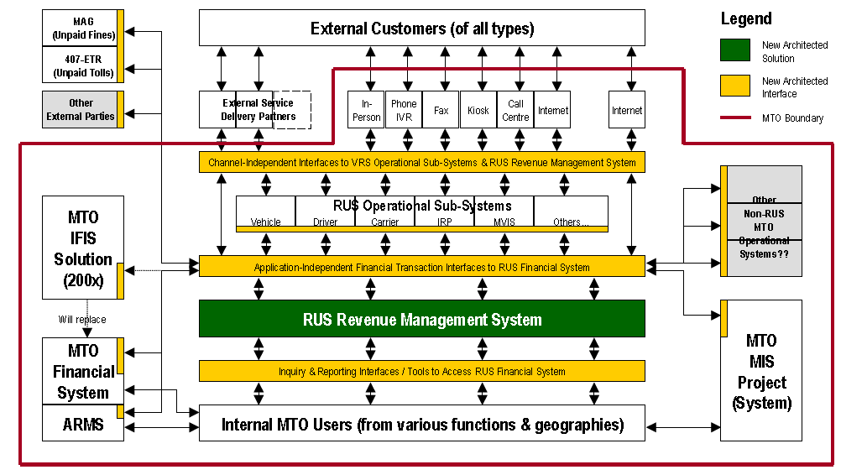

#### Project Organization

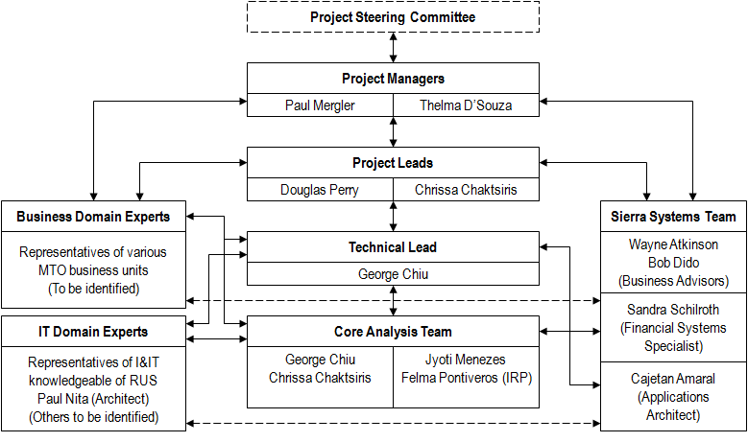

#### Project Inter-relationship

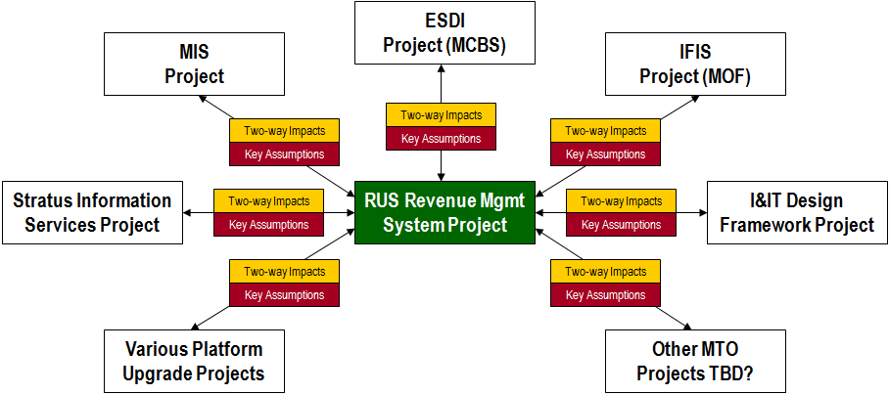

#### Conceptual High-Level Architecture

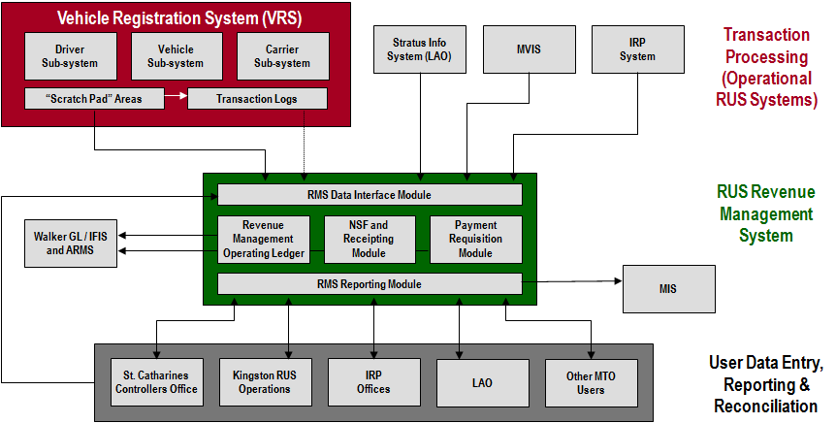

#### Future Revenue System

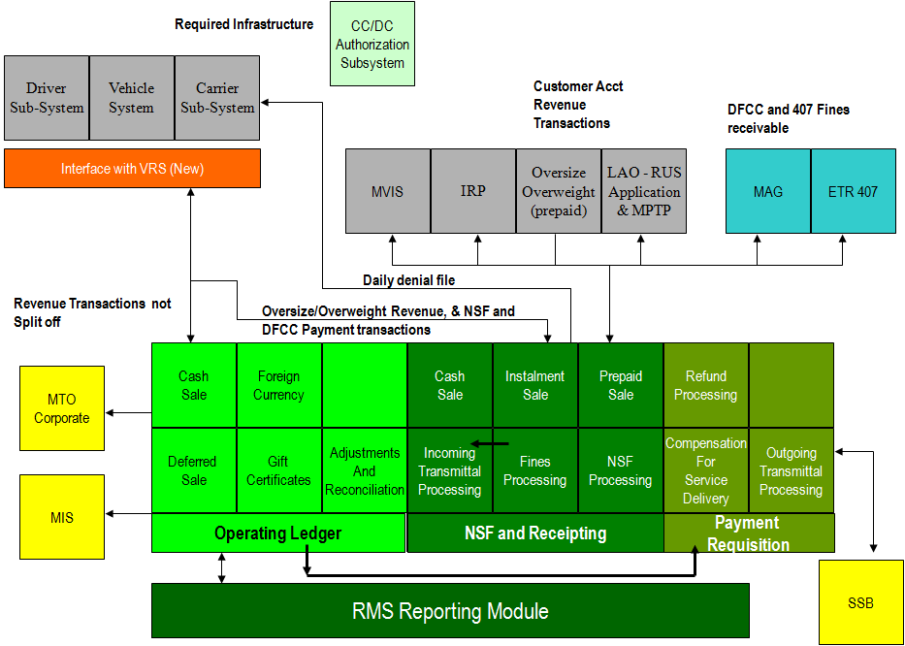

## FINTECH Payment Sector

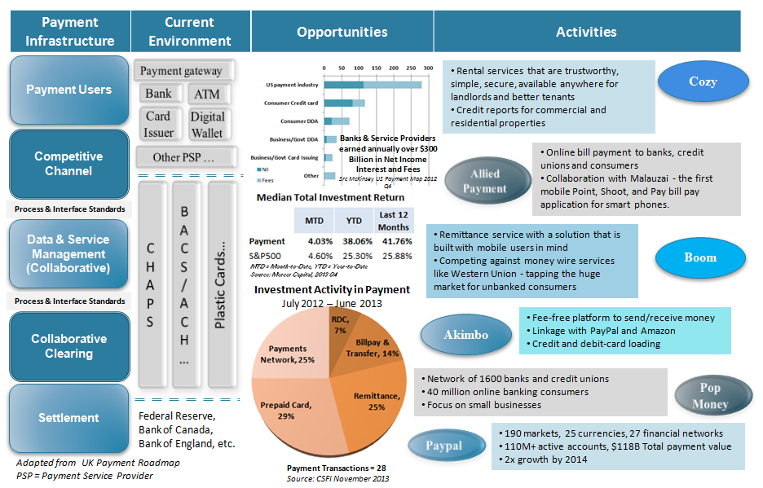

## FINTECH Specialty Credit Sector

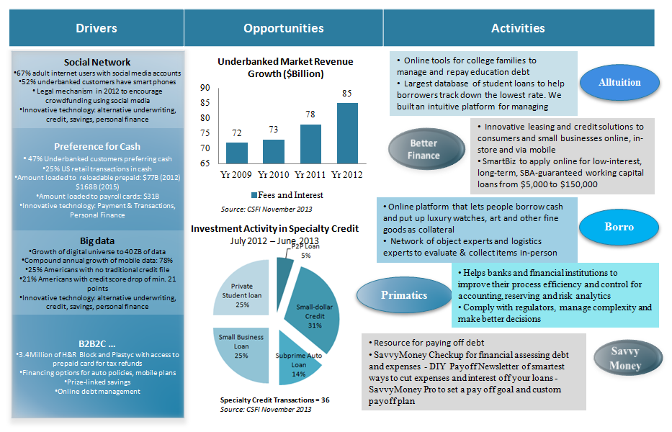

## On IBM ALGORITHMICS

